**Analysis of Puerto Rico Timeseries Reports**

**Author(s): Alexander X. Gonzalez-Torres**

*Below, I include time-series visualizations made by this project’s pipeline for the Commonwealth of Puerto Rico. From the report, I include indicators that were seemingly affected by Hurricane Maria. I add some notes with context on the indicator and what the visualization suggests.*

*Notes:*

*2008: Great Recession*

*< 2009: Acevedo Vila Administration*

*2009: "Fortuño Administration",*

*2013: "Garcia Padilla Administration"*

*2019: "Roselló-Pierluisi-Vazquez Administration"*

*2020: COVID-19/2020 earthquakes*

*2021: LUMA takes over energy transmission and distribution.*

*2023” Genera PR takes over power plants.*

META:

1. Hurricane Maria has affected Food and Livestock production long-term.
2. People’s perceptions of government corruption and effectiveness went down following Hurricane Maria. Perceptions of effectiveness never improved.
3. Emissions are up across a number of sectors—Methane, CO2, N20—providing credence to the fact that Hurricane Maria permanently affected Puerto Rico’s power grid, increasing its reliance on fossil fuels; both at the government and household levels.
   1. Total N20 emissions are down. Same as Methane. C20 is up in the same metric. Did the grid get worse? Is C20 worse? Maybe it’s a combination of that and Ag/Livestock/Industry being affected.
4. Reconstruction after Maria probably affects these too.
5. Puerto Rico may just be a less productive and less sophisticated country with further reliance on foreign sources for help… but does US count as foreign here?
6. Deflationary pressures – Puerto Ricans have less savings and things are cheaper than in the mainland post Maria
7. Education – more parity in the tertiary level, more children out of school, those in school are private. There’s discrepancies for primary and secondary-tertiary. Some interesting dynamics here.

NOTES:

** There are plots missing from the shorter PRI report that are available in the longer one. Look into why that is. I bet it’s those with very long sharp lines. The transform step probably has to do with it.

** Look into standard error for perception (corruption, effectiveness) metrics.

** If you see very long horizontal lines, the data may be trash. Our transform step caused that. Check the ‘extracted’ CSV to confirm. Some long lines are the product of forward-filling NULL values. For PRI, it seems like post-2020 data is spotty.

** ANYTHING BEFORE GOV EFFECTIVENESS, CHECK FOR SENSITIVITY WITH EXTRACTED CSV.

** CONSTANT LCU IS GREAT FOR ECONOMIC DATA, TRACKS REAL CHANGES.

PRI: Arable land (hectares per person) and PRI: Arable land (hectares), in conjunction, demonstrate that Hurricane Maria lowered the population of Puerto Rico. Over 4000 people died, and many left for the mainland U.S.

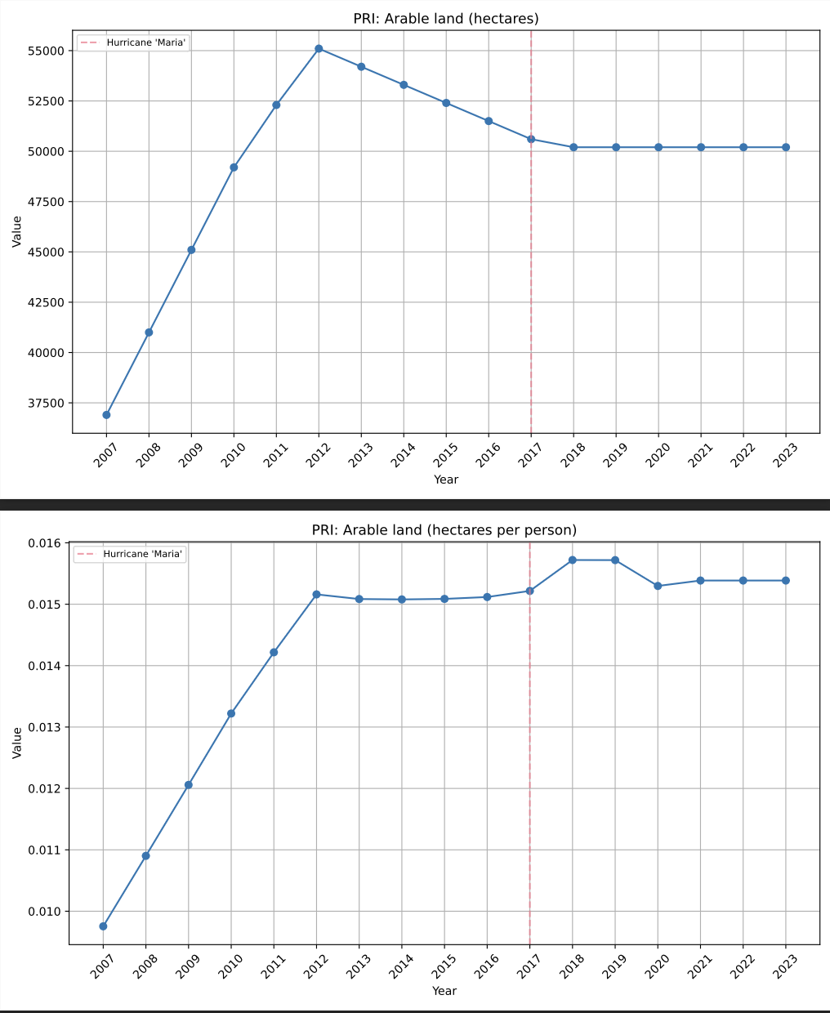

PRI: Food production index (2014-2016 = 100) and PRI: Livestock production index (2014-2016 = 100). These indexes are pegged to production between 2014-2016. Values above 100 suggest growing production, below 2017 falling production. 2016 to 2017 was relatively stable, and a big drop off happens after 2017. Suggests diminished production after Maria.

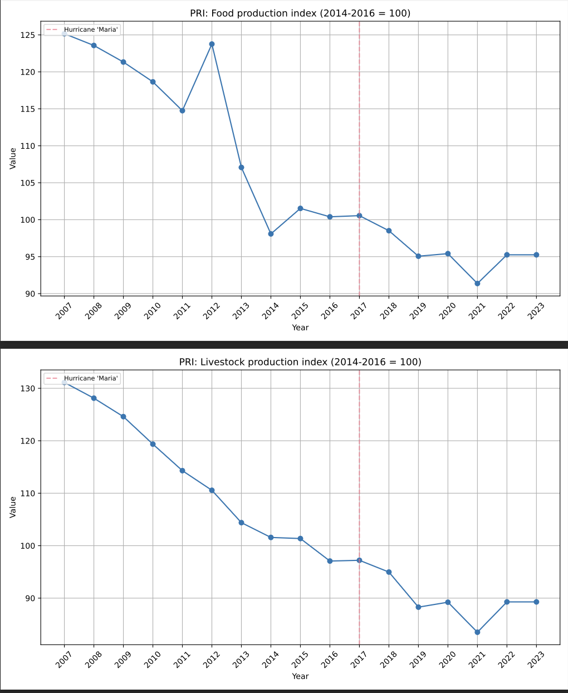

PRI: Control of Corruption: Estimate

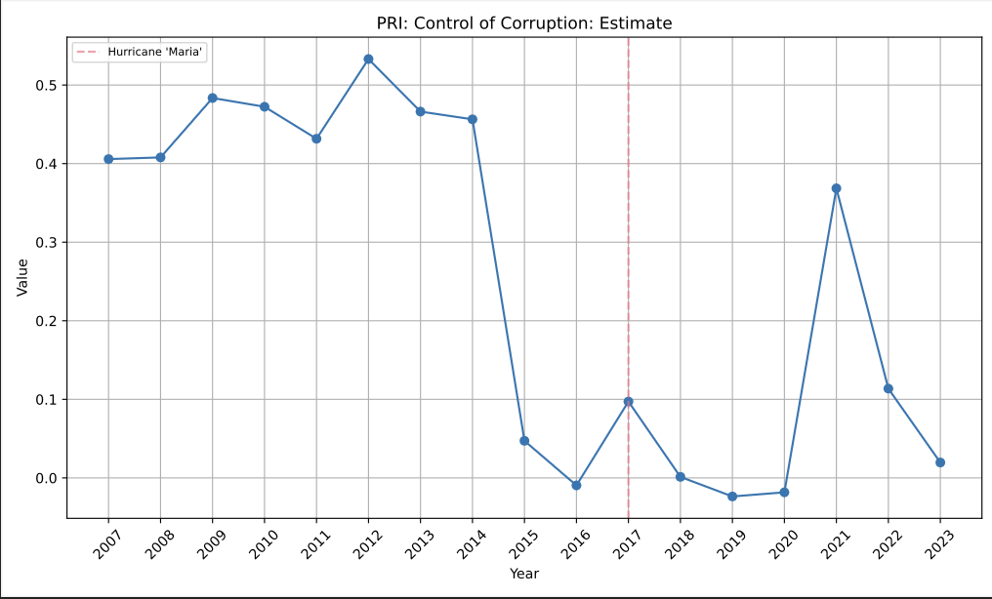

This index measures perceptions of corruption in public power. A higher value suggests better control of corruption, while a lower value indicates weaker control or higher corruption perceptions. Values range approximately between -2.5 (poor control) and 2.5 (strong control).

The are upward spikes around 2017 (Maria) and 2021 (COVID), which coincide with ‘rally around the flag’ phenomena following national tragedy (George W Bush was incredibly popular after 9/11, for example).

Notice a dip into negative territory in the years following Hurricane Maria, which coincides with the negative public sentiment that led to the Summer of 2019 protests that brought down the Rosselló, Jr. administration. Among other things, perceptions of mismanaging the response to Maria led to these protests.

There is an uptick after his resignation (2020), but plummets once more, below levels seen after Hurricane Maria. It suggests the public’s perception of government corruption has not recovered to pre-Maria levels, rally round the flag effects aside.

PRI: Energy intensity level of primary energy (MJ/$2017 PPP GDP). The metric “Energy intensity level of primary energy (MJ/$2017 PPP GDP)” measures the amount of primary energy (in megajoules, MJ) required to generate one unit of economic output, expressed in terms of purchasing power parity (PPP) GDP at constant 2017 US dollars.

**Primary Energy**:

Refers to energy sources in their natural state (e.g., crude oil, coal, natural gas, solar energy) before being converted into usable energy like electricity or heat.

This metric tracks how much energy is consumed across all sectors, including transportation, industry, and household

**PPP GDP:**

Adjusts GDP for differences in the cost of living between countries, providing a more accurate comparison of economic output.

**Energy Intensity**:

A higher value means more energy is required to produce economic output, indicating inefficiency.

A lower value means less energy is required, indicating greater efficiency or a transition to cleaner, more efficient energy systems.

Puerto Rico is very unproductive following Hurricane Maria. Maybe it’s relying on gas, and those went up? Or maybe the grid is just that bad.

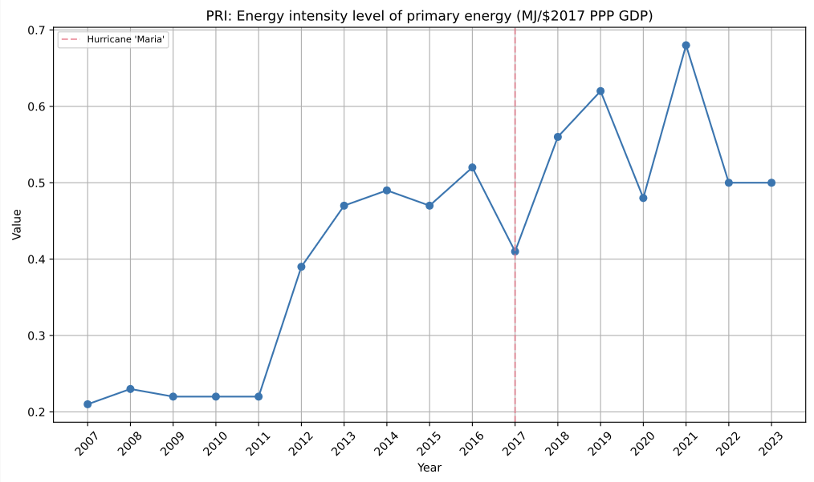

PRI: Total greenhouse gas emissions excluding LULUCF (Mt CO2e). CO2 emissions went up, in aggregate, following H.M. and have not recovered.

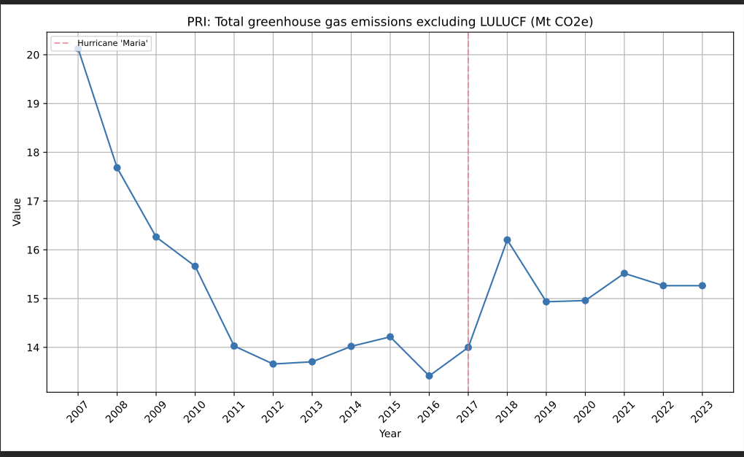

PRI: Renewable energy consumption (% of total final energy consumption). The small blip after Hurricane Maria here, and a prompt recovery, suggests that CO2 emissions going up doesn’t have to do with a fall in use in renewable resources. The grid is just using more fossil fuels, and using them less efficiently, it seems like.

Maybe there’s some correlation with renewable energy consumption? It did go down after Maria, but then normalizes into the upwards trend it’s been on for a while. Green house emissions don’t follow an inverse correlation, yet they still go up.

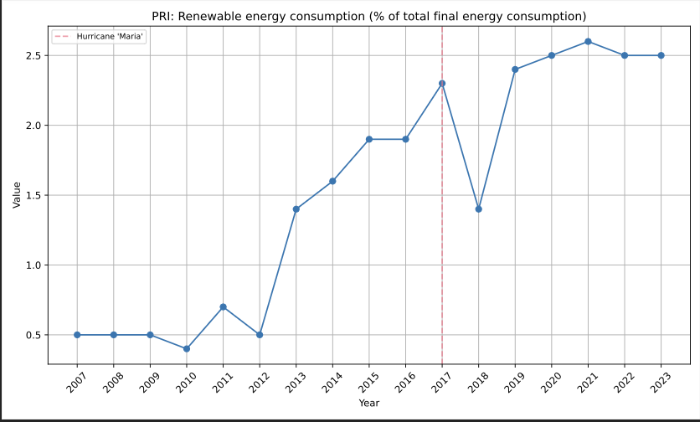

\\\\\\\\\\\\\\\\\\\\\\\\\\\\\\

**\\\\\ ENERGY -> \\\\\**

**\\\\\\\\\\\\\\\\\\\\\\\\\\\\\\\**

**METHANE**

PRI: Methane (CH4) emissions from Agriculture (Mt CO2e). Up, slowly recovering. The figure isn’t terribly significant, though.

PRI: Methane (CH4) emissions from Building (Energy) (Mt CO2e). Energy consumed within residential, commercial, and industrial buildings. It sharply went up after Maria (gas power plants?) and has stayed that way (bad grid?).

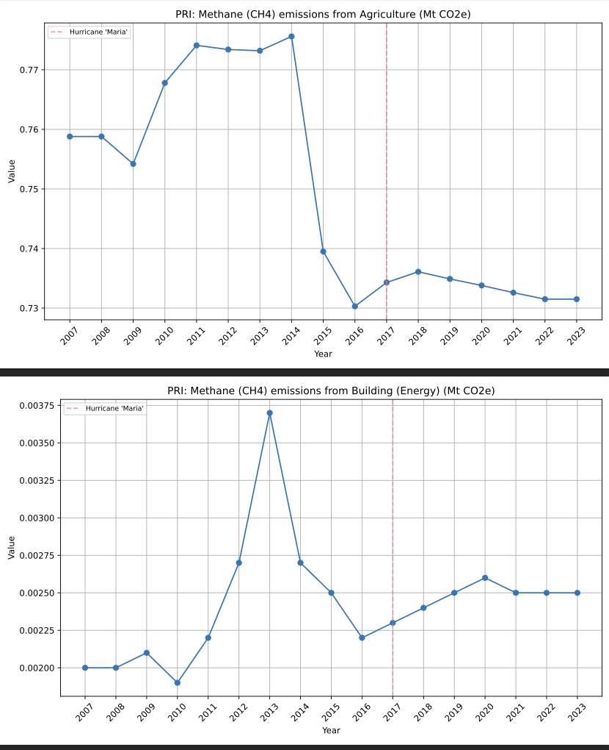

PRI: Methane (CH4) emissions from Fugitive Emissions (Energy) (Mt CO2e).

Fugitive emissions refer to the unintentional release of greenhouse gases (GHGs) or other pollutants into the atmosphere during the production, processing, storage, transmission, or distribution of fuels and industrial processes.

Sources of Fugitive Emissions

1. Energy Sector

• Oil and Gas Operations:

• Leaks from pipelines, storage tanks, and equipment during oil and natural gas extraction, processing, and transport.

• Release of methane (CH₄) during fracking or venting.

• Coal Mining:

• Methane release from coal seams during underground or surface mining operations.

2. Industrial Processes

• Chemical Manufacturing:

• GHG leaks (e.g., fluorinated gases like HFCs) from refrigeration, air conditioning, or industrial cooling systems.

• Cement and Aluminum Production:

• Process emissions from chemical reactions in the manufacturing process (e.g., CO₂ from lime in cement).

3. Agriculture and Waste

• Landfills:

• Release of methane from decomposing organic waste in landfills.

• Wastewater Treatment:

• Fugitive methane and nitrous oxide (N₂O) from organic matter decomposition in treatment facilities.

Puerto Rico had some recovery during COVID. I suspect Industrial Processes since people were at home. Things promptly went back up to post-Maria levels. The grid is likely to blame. Perhaps wastewater treatment too.

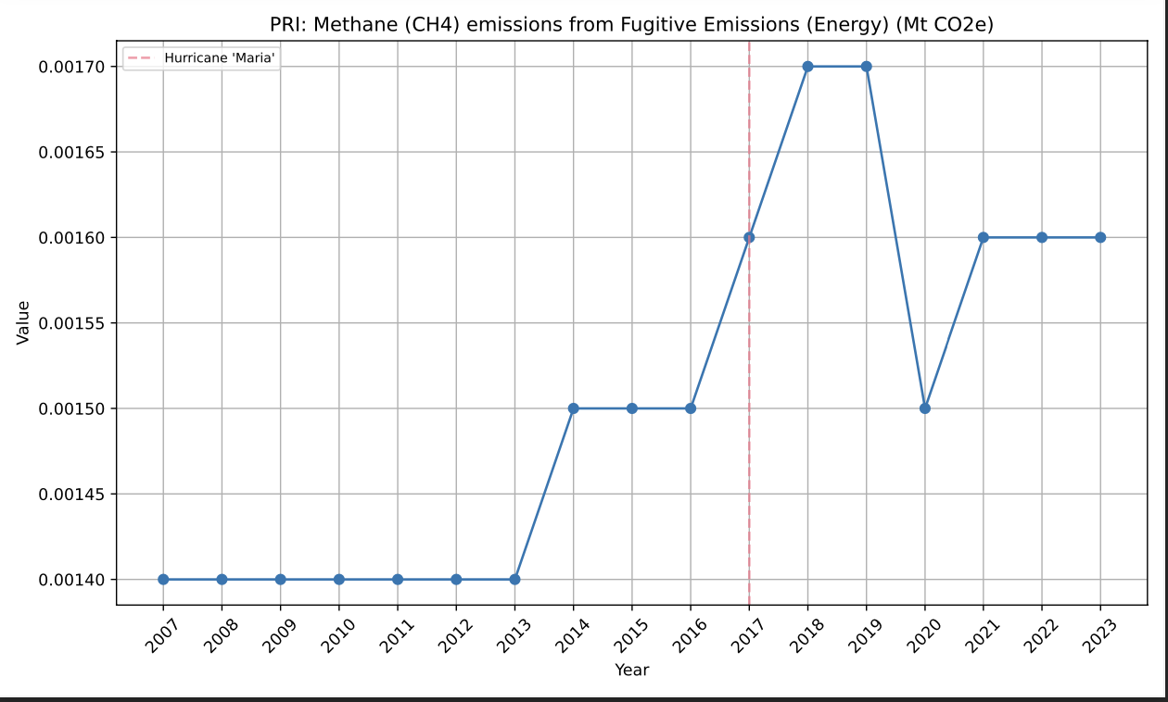

PRI: Methane (CH4) emissions from Industrial Combustion (Energy) (Mt CO2e). Industrial combustion refers to the burning of fuels in industrial processes to generate energy, typically in the form of heat or power, for a wide variety of applications. This energy is essential for running equipment, heating materials, and producing goods in industries such as manufacturing, power generation, chemical production, and more.

Seems like Maria killed some industrial institutions. Maybe we see effects on the economy.

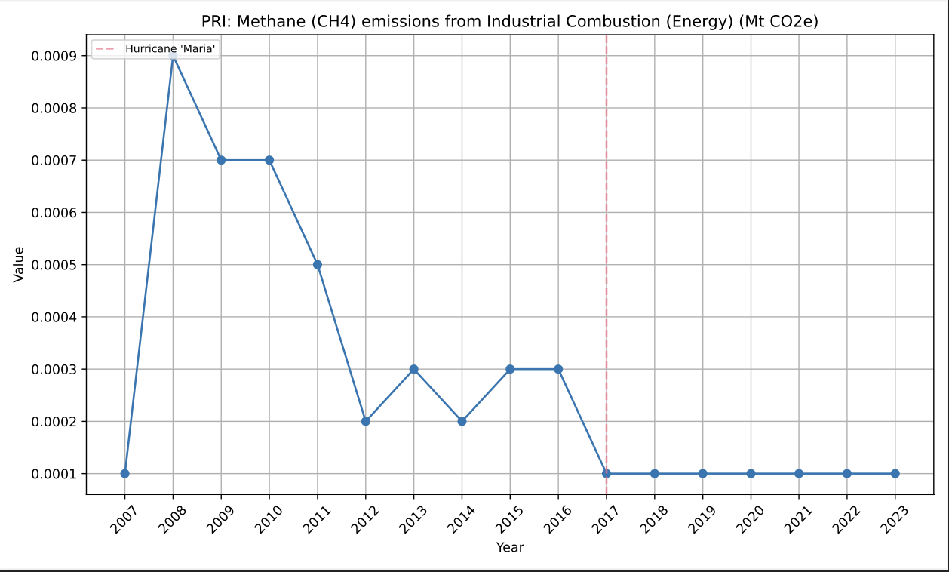

PRI: Methane (CH4) emissions (total) excluding LULUCF (Mt CO2e). Total Methane emissions are following a downwards trend, though. Maybe it’s because Puerto Rico’s livestock industry and agriculture has been going downwards. CO2 and N20 are up in aggregate, though. So those 2 come from different sources, at least the bulk of it.

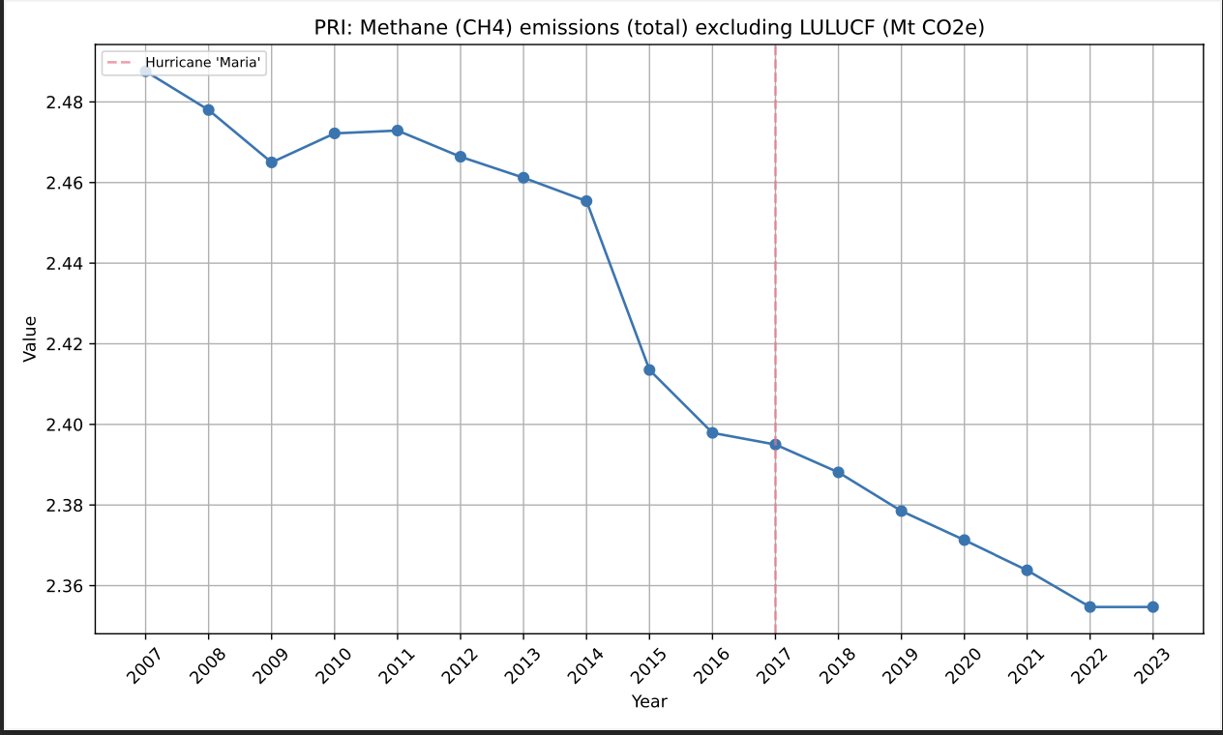

PRI: Methane (CH4) emissions from Power Industry (Energy) (Mt CO2e). Yeah. **It really does seem like the grid is to blame.** It’s less efficient and less green in aggregate now.

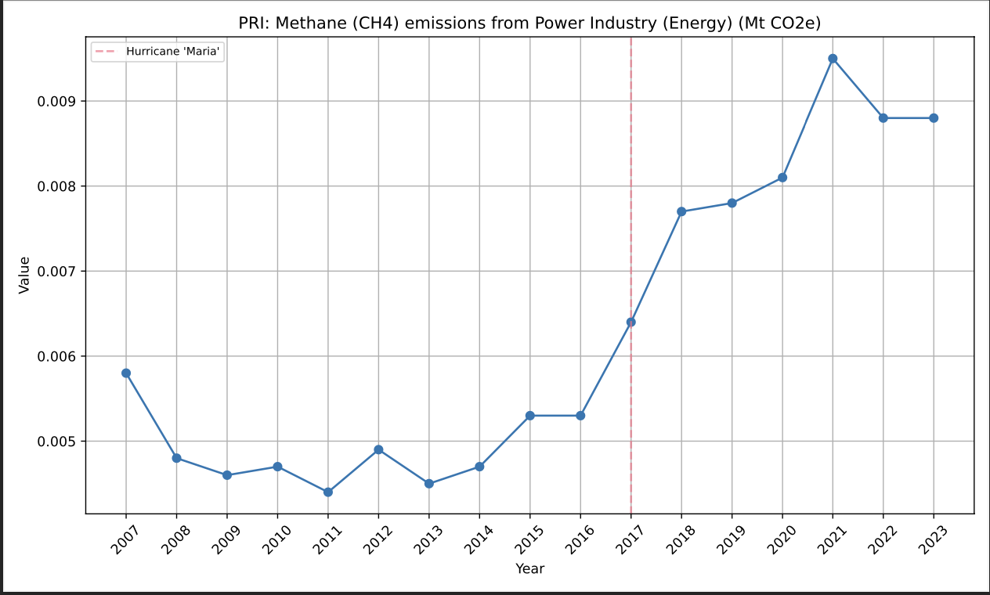

PRI: Methane (CH4) emissions from Transport (Energy) (Mt CO2e)

PRI: Methane (CH4) emissions from Waste (Mt CO2e). It’s neither of these two, which adds to my Grid Theory.

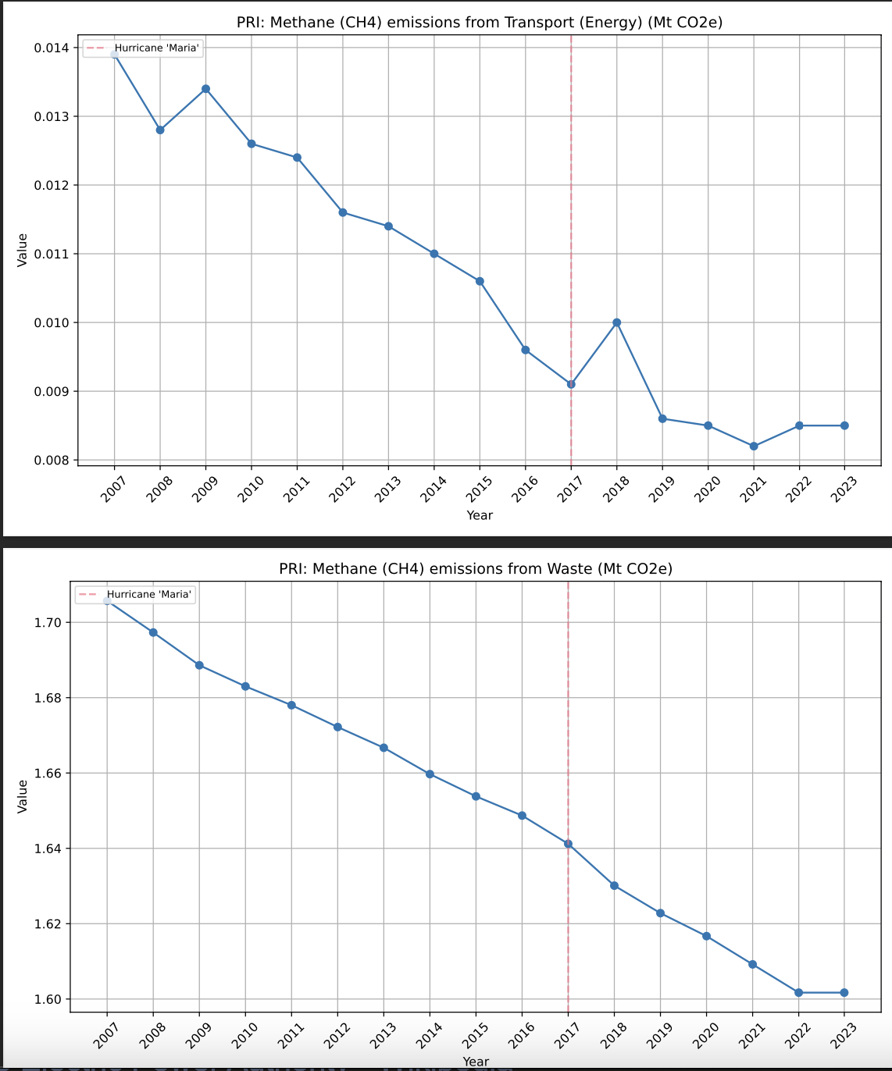

**CARBON DIOXIDE**

PRI: Carbon dioxide (CO2) emissions from Building (Energy) (Mt CO2e). CO2 in buildings is up after COVID and stabilizes around 2020. Follows the trend with Methane.

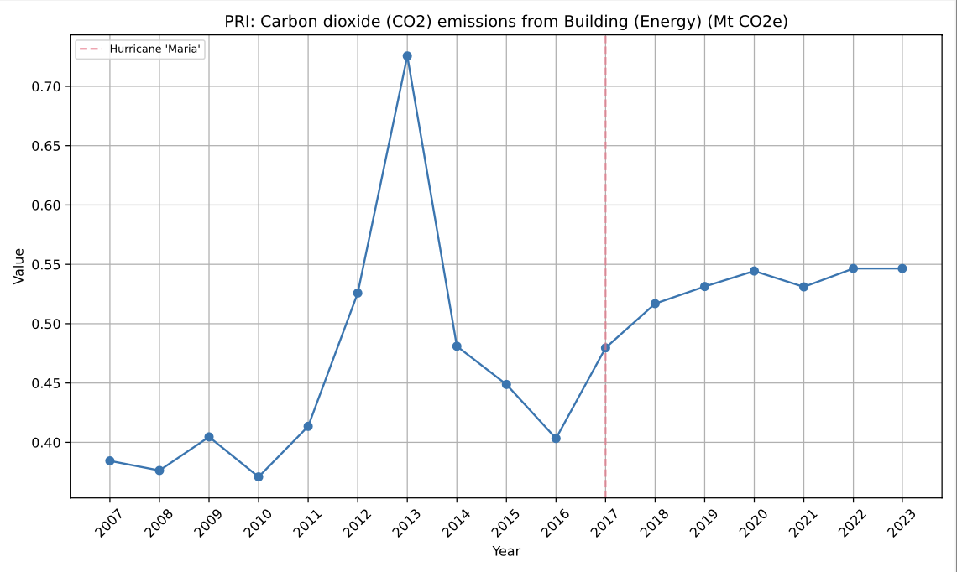

PRI: Carbon dioxide (CO2) emissions from Fugitive Emissions (Energy) (Mt CO2e). Slowly trending up after HM.

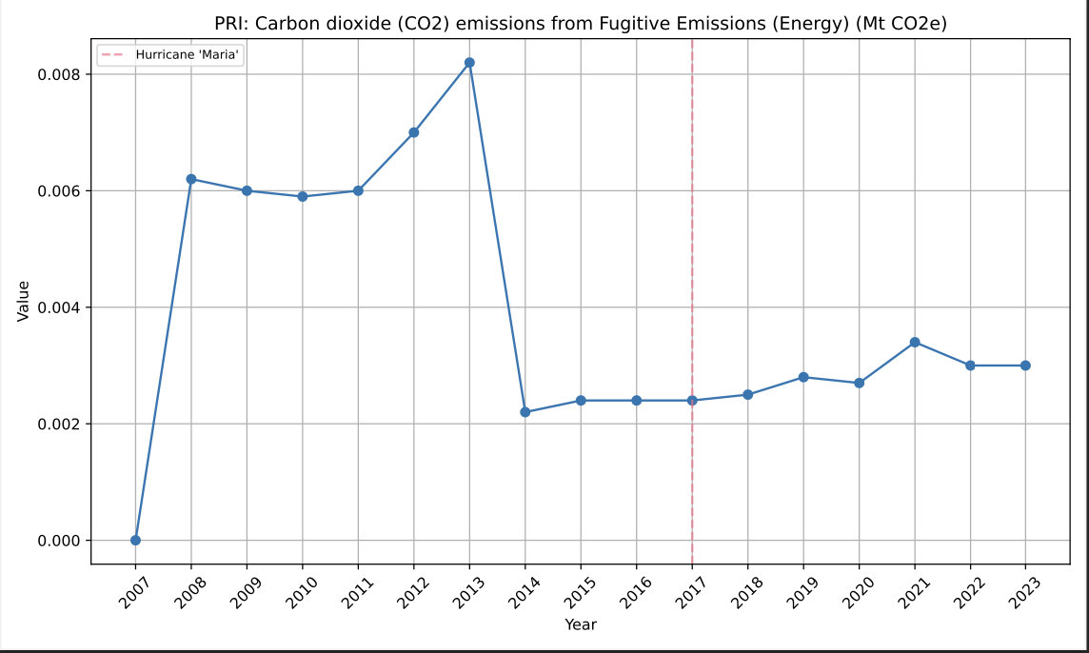

PRI: Carbon dioxide (CO2) emissions from Industrial Combustion (Energy) (Mt CO2e). Aligned with Methane.

PRI: Carbon dioxide (CO2) emissions (total) excluding LULUCF (Mt CO2e). Up since HM, has not recovered. Stabilized high.

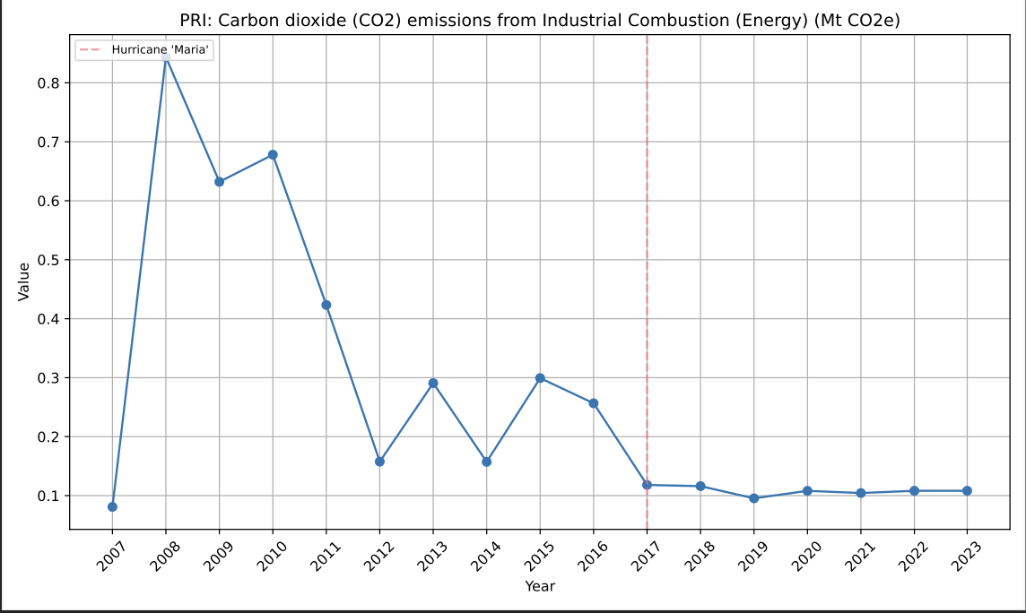

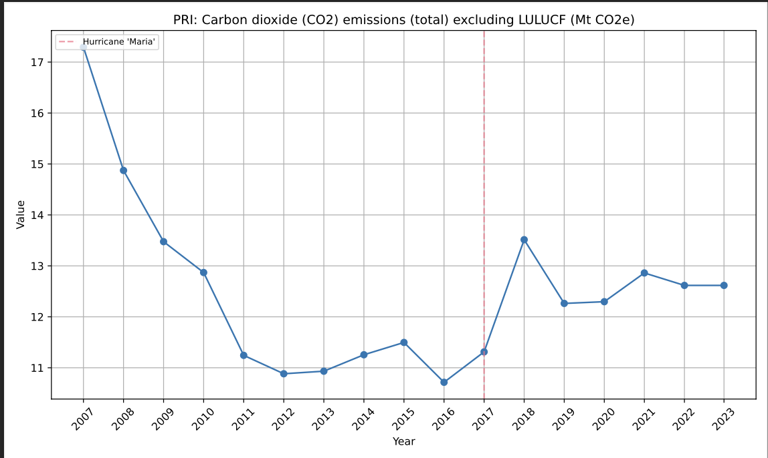

PRI: Carbon dioxide (CO2) emissions from Power Industry (Energy) (Mt CO2e). The grid is most definitely to blame for the uptick in CO2. The lines seem 1:1 correlated. Look at the shape.

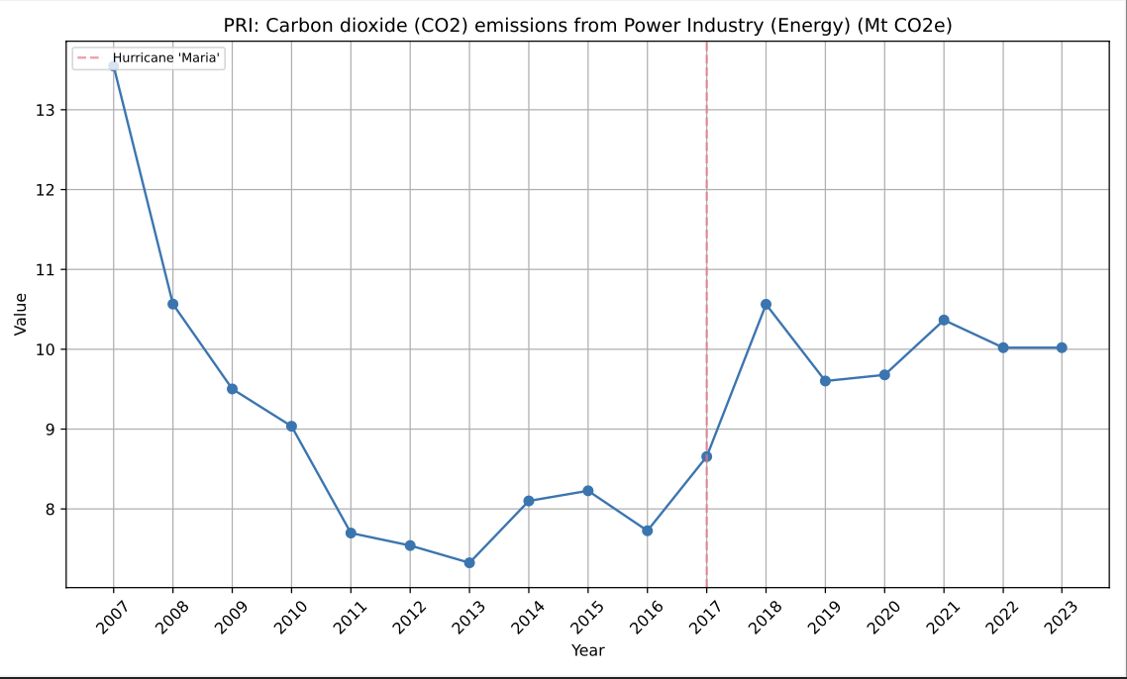

PRI: Carbon intensity of GDP (kg CO2e per constant 2015 US$ of GDP). The metric “Carbon intensity of GDP (kg CO₂e per constant 2015 US$ of GDP)” measures the amount of carbon dioxide equivalent (CO₂e) emissions generated for each unit of economic output, expressed in constant 2015 US dollars. It reflects the relationship between a country’s economic productivity and its greenhouse gas emissions.

What This Metric Tells Us

1. Environmental Efficiency of the Economy:

• Lower carbon intensity: Indicates greater energy efficiency or cleaner energy use, where the economy produces more output with fewer emissions.

• Higher carbon intensity: Suggests greater reliance on carbon-intensive activities, such as fossil fuel combustion or energy-intensive industries.

2. Progress Toward Decarbonization:

• A declining trend in carbon intensity signals progress toward reducing greenhouse gas emissions while maintaining or growing the economy.

• Stable or increasing carbon intensity may indicate stagnation in efforts to decarbonize.

3. Economic Structure:

• Economies reliant on heavy industry or fossil fuels tend to have higher carbon intensity.

• Economies dominated by services or technology sectors typically exhibit lower carbon intensity.

What This Means for Puerto Rico (PRI)

1. Challenges:

• Fossil Fuel Dependency: Puerto Rico generates most of its electricity from imported fossil fuels (e.g., oil, coal, and natural gas), contributing to higher carbon emissions relative to GDP.

• Energy-Intensive Recovery Efforts: Post-disaster rebuilding efforts, such as after Hurricane Maria in 2017, can temporarily increase emissions without a corresponding increase in economic output.

• Economic Fragility: A weaker economy may cause higher carbon intensity if emissions remain constant or rise while GDP stagnates or declines.

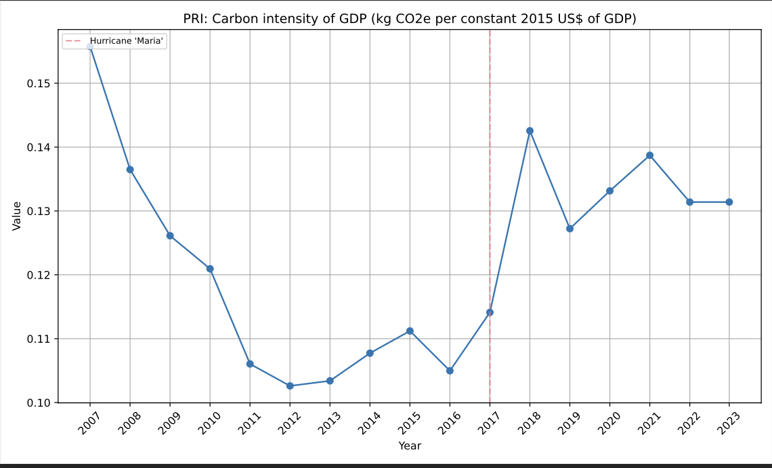

PRI: Carbon dioxide (CO2) emissions from Transport (Energy) (Mt CO2e). Aligns with the trend in Methane.

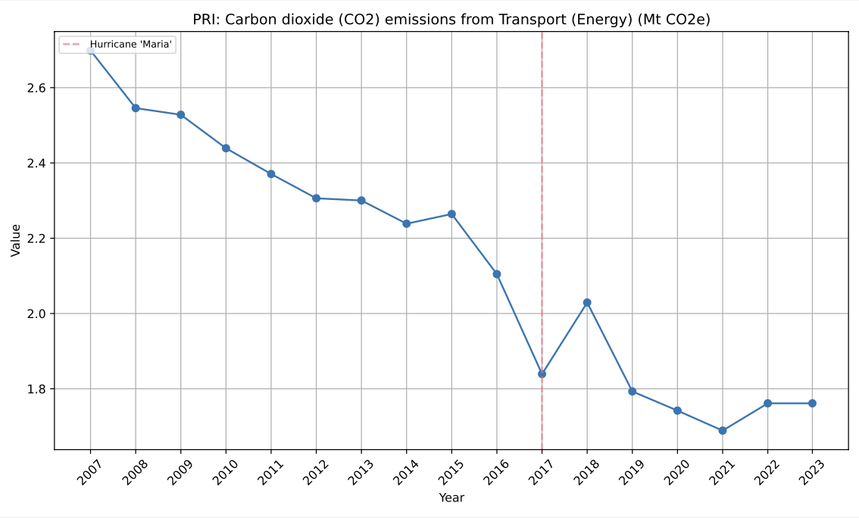

**NITROUS OXIDE**

PRI: Nitrous oxide (N2O) emissions from Agriculture (Mt CO2e). N20 from Agriculture went up after Maria and has never recovered. Fertilizers and crop residue (rotting plants) could be it. It’s not livestock since that index is down. Poorly drained fields and disturbed land also to blame.

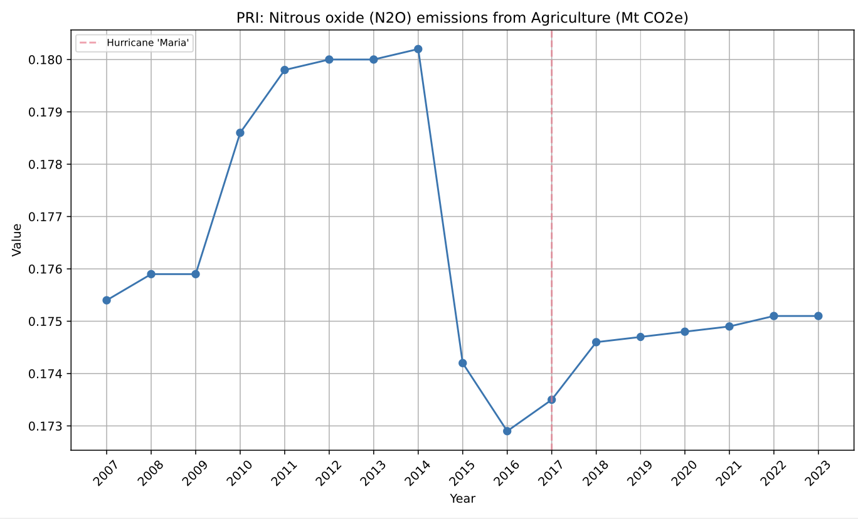

PRI: Nitrous oxide (N2O) emissions from Industrial Combustion (Energy) (Mt CO2e). PRI: Nitrous oxide (N2O) emissions from Industrial Processes (Mt CO2e) Further support to the idea that industry in PRI was affected after Maria. Combustion needs changed, but industry emissions went up. Rebuilding?

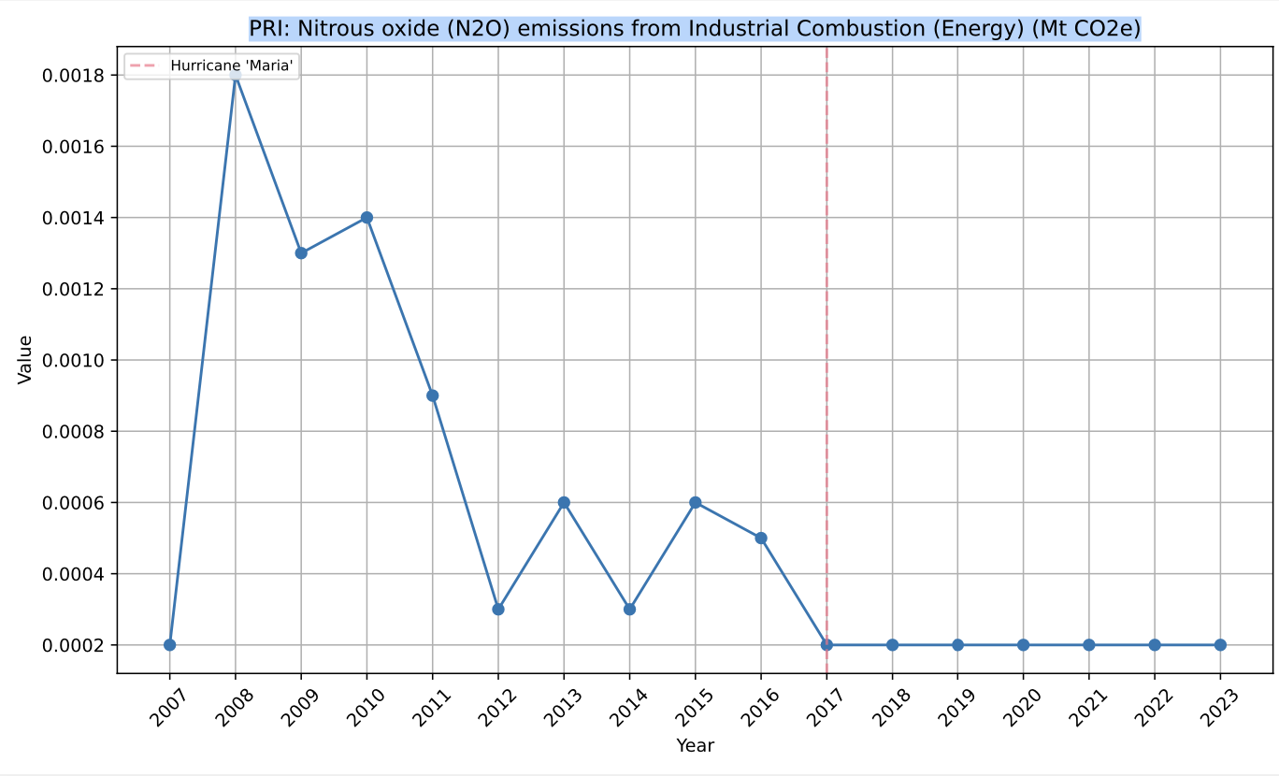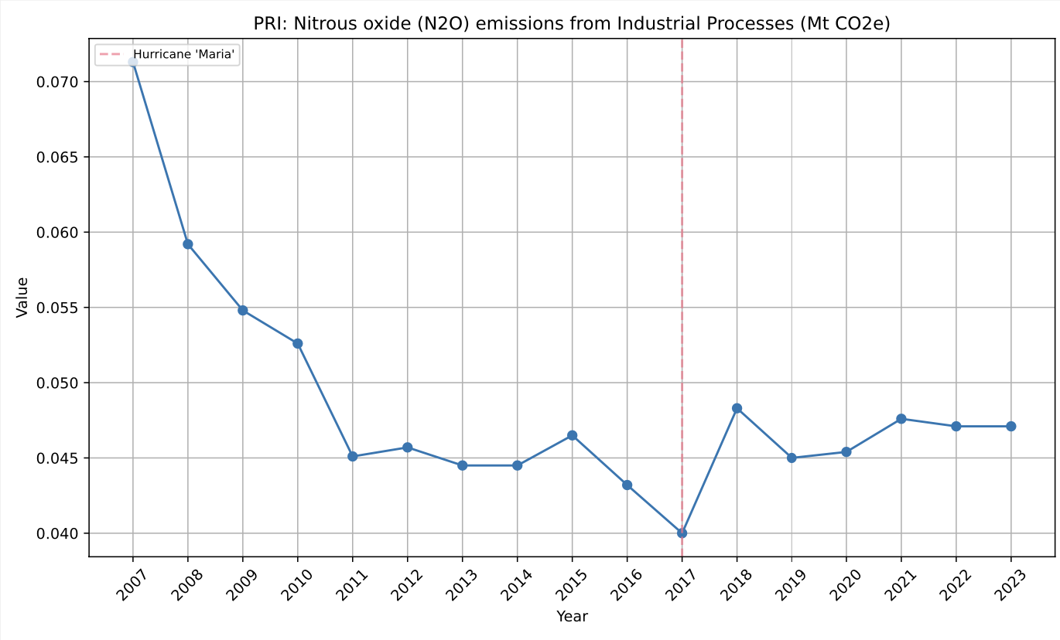

PRI: Nitrous oxide (N2O) emissions (total) excluding LULUCF (Mt CO2e). Total N20 emissions are down. Same as Methane. C20 is up in the same metric. Did the grid get worse? Is C20 worse? Maybe it’s a combination of that and Ag/Livestock/Industry being affected.

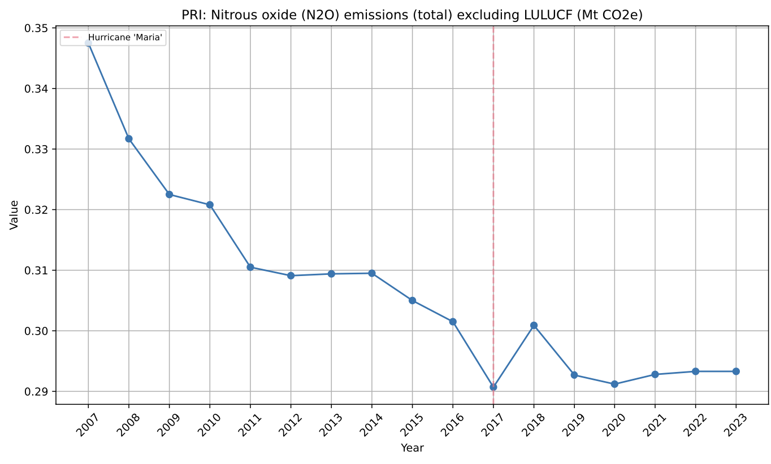

PRI: Nitrous oxide (N2O) emissions from Power Industry (Energy) (Mt CO2e). Well N20 from the grid has been coming down for a while in Puerto Rico, and it was doing the same for C02, but it then spiked over there after Maria and hasn’t come down. Maybe my worse fuels/poor efficiency hypothesis is right?

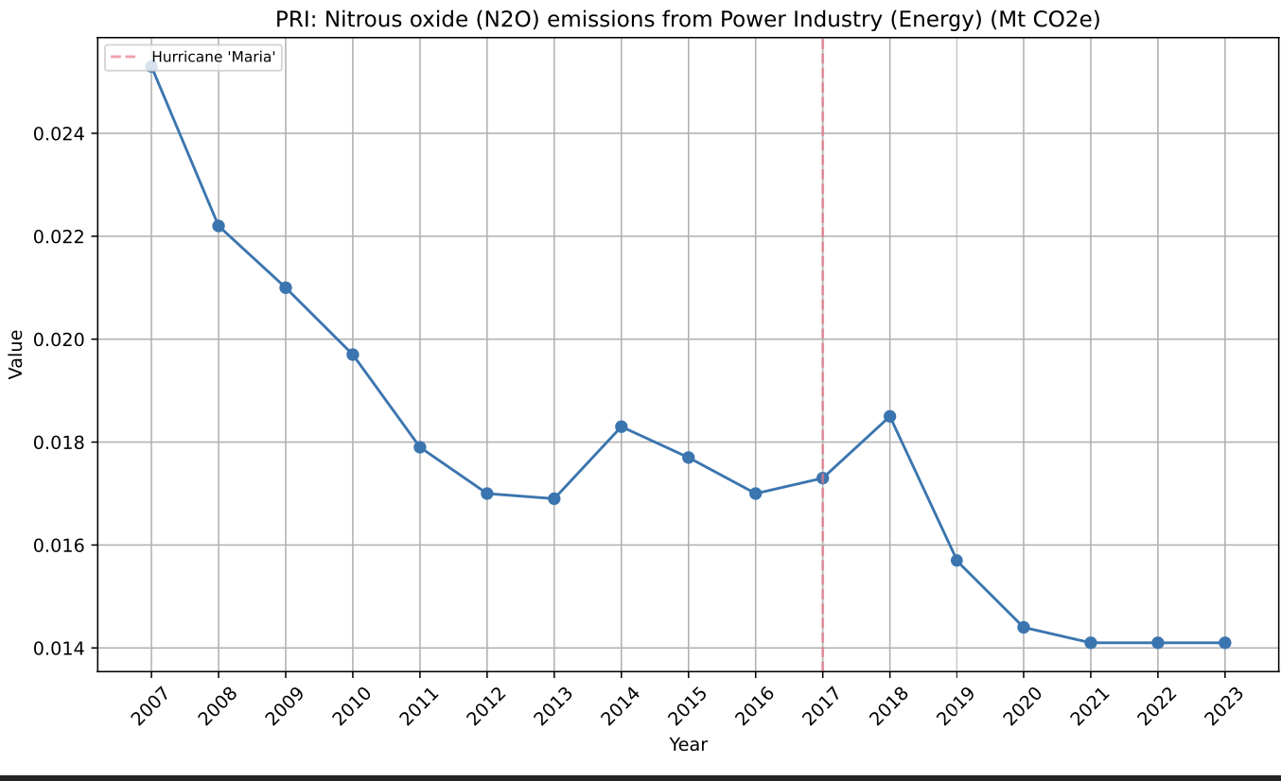

PRI: Nitrous oxide (N2O) emissions from Transport (Energy) (Mt CO2e). It definitely seems to be the grid, it hasn’t have to do with say, Transport.

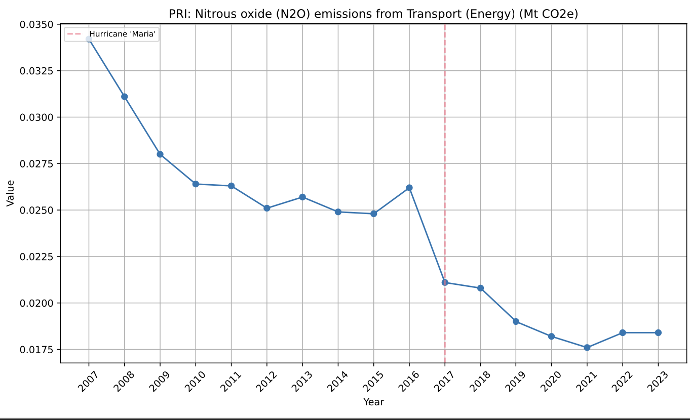

PRI: Nitrous oxide (N2O) emissions from Waste (Mt CO2e). Does plant matter count as waste? Maybe the landfills were disturbed? This one is crazy. I need to look more into it.

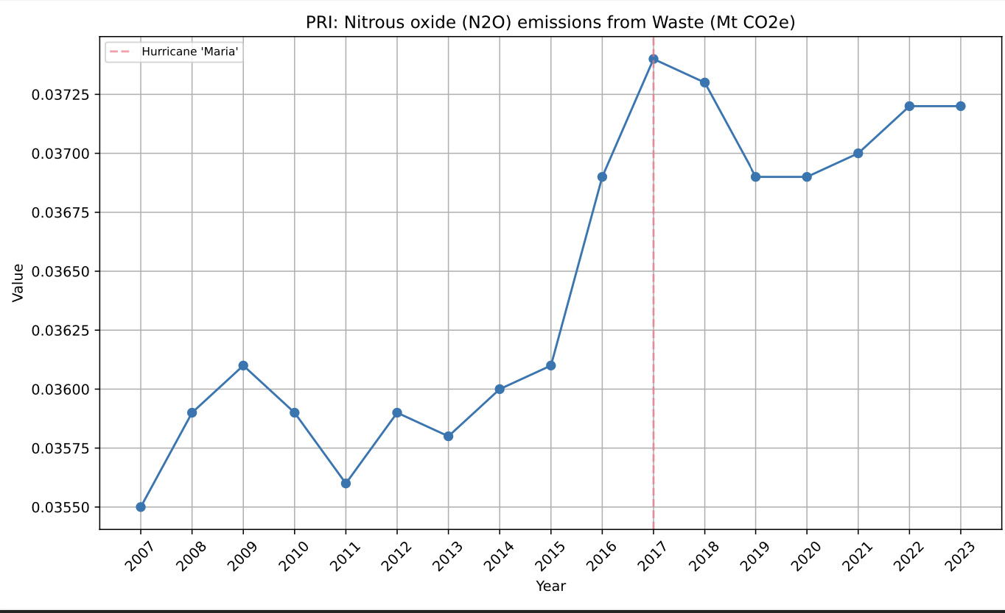

\\\\\\\\\\\\\\\\\\\\\\\\\\\\\\

**\\\\\ <- ENERGY \\\\\**

**\\\\\\\\\\\\\\\\\\\\\\\\\\\\\\\**

PRI: Total fisheries production (metric tons) . More food production issues, now with fish.

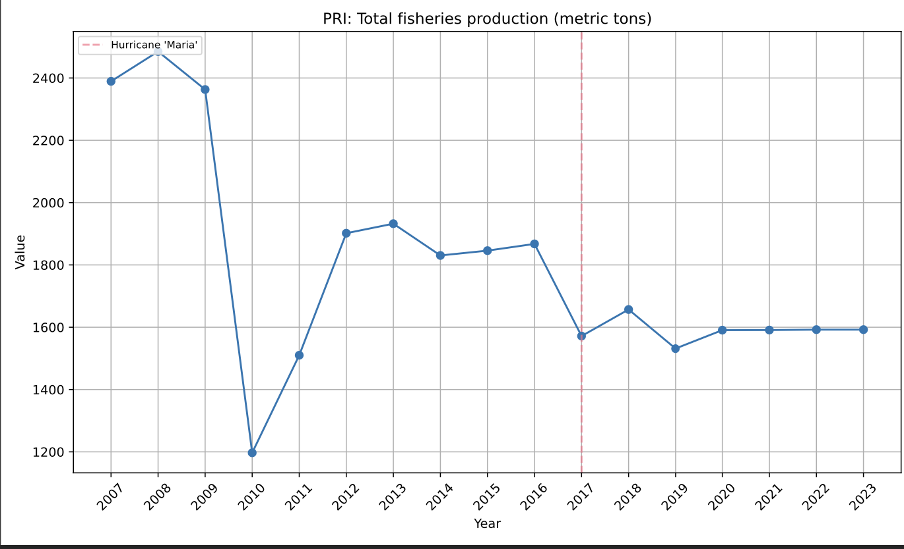

PRI: Government Effectiveness: Estimate. Same as the corruption index. Perception still not up.

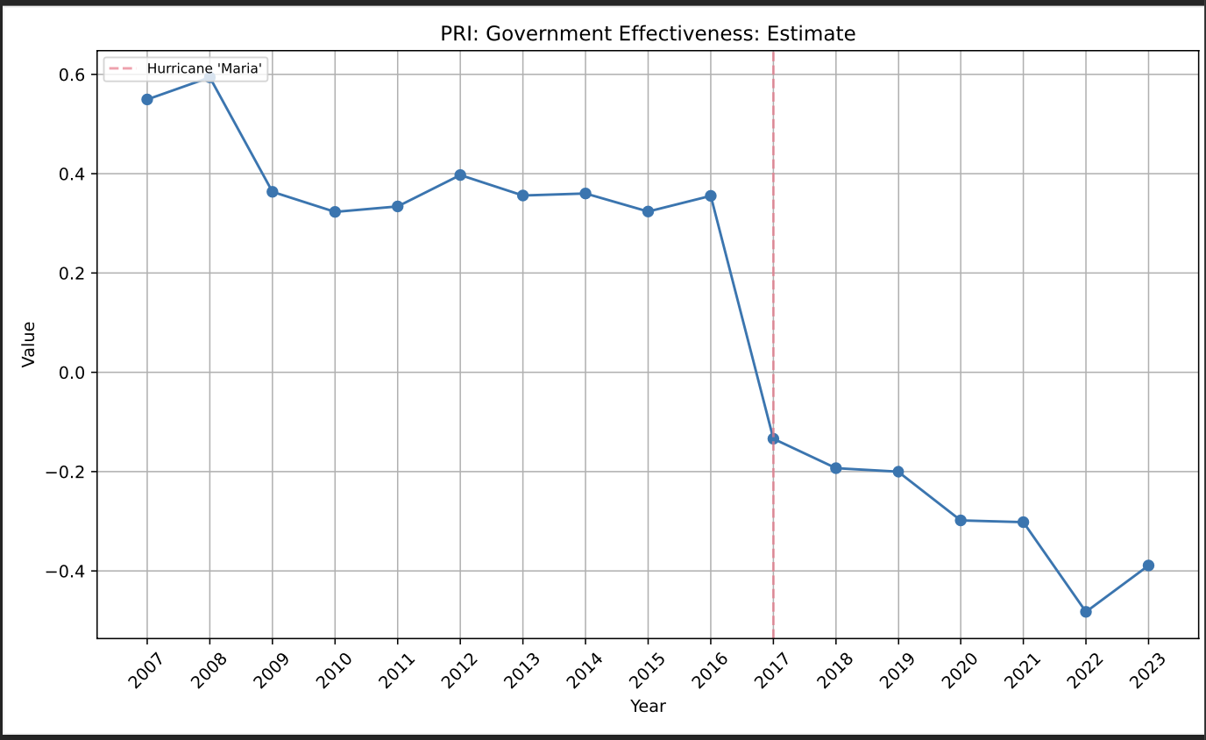

PRI: Exports of goods and services (current US$). Exports going down tracks with Food and Livestock indexes. Perhaps with industry. Services – brain drain post Maria. Combine with PRI: Fixed telephone subscriptions (per 100 people) and it sure seems like that. Especially the mutual fall and recovery.

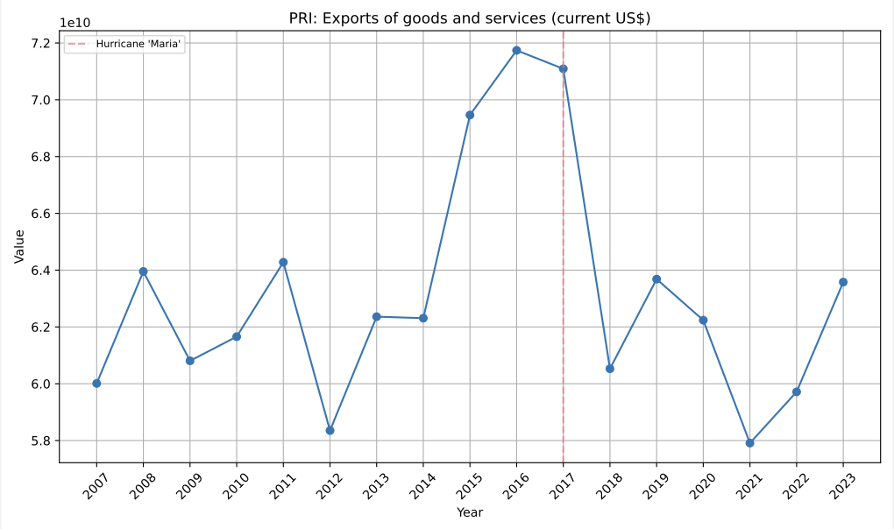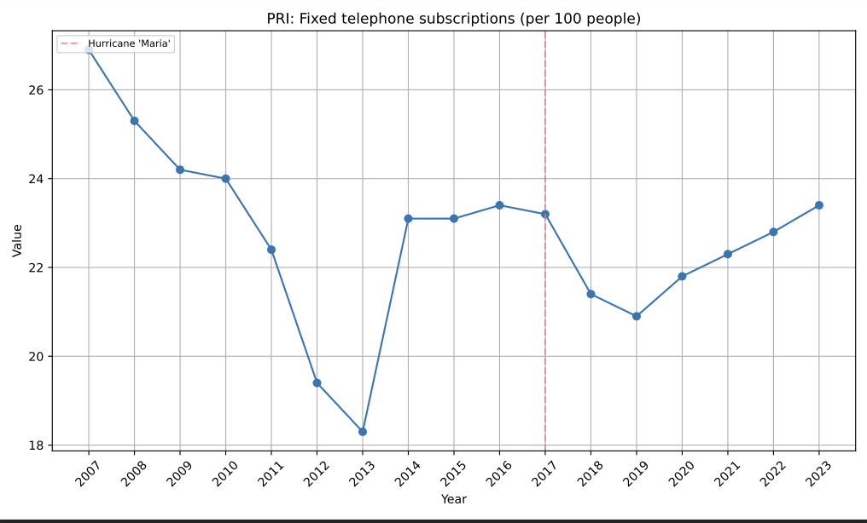

PRI: Exports of goods and services (% of GDP). The economy became less sophisticated, if the brain drain is true, and with the COVID double whammy it just can’t recover. I need more data on exports to make an assessment, but the brain drain has been true for a while.

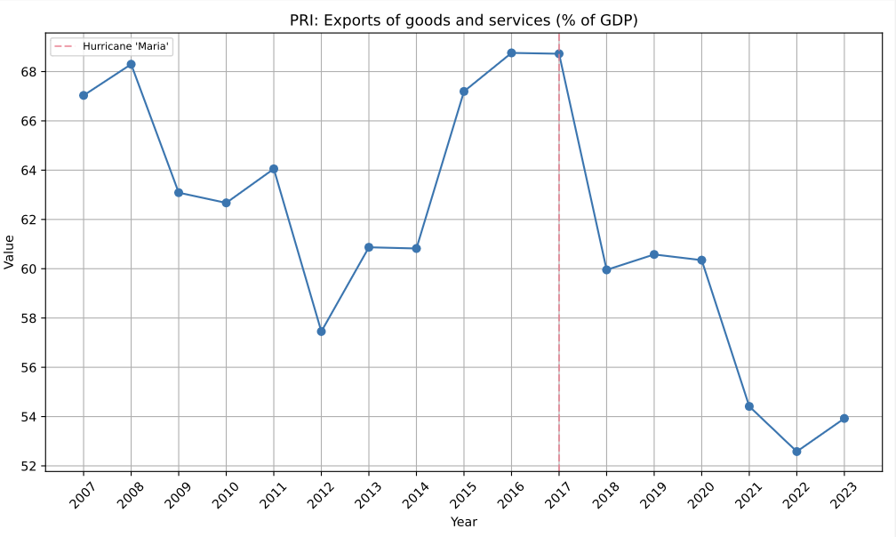

PRI: Gross fixed capital formation, private sector (% of GDP). Private sector has to invest to get things back running. Could coincide with port data… but there’s no export of goods and services… was it all internal, or were private investors just scooping up capital?

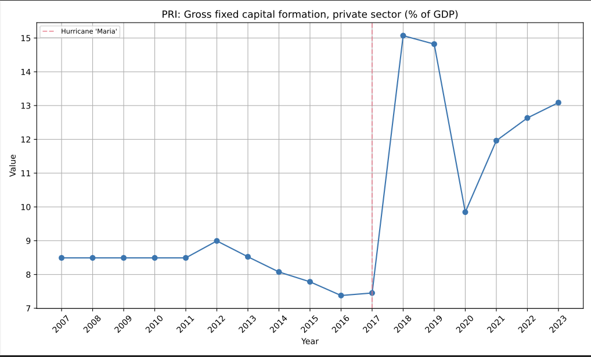

PRI: Gross fixed capital formation (annual % growth). A dead economy is jolted awake, maybe that explains some of the emissions stuff. Recovery. That’s sad.

But, did the government issue a lot of debt? Like more than usual?

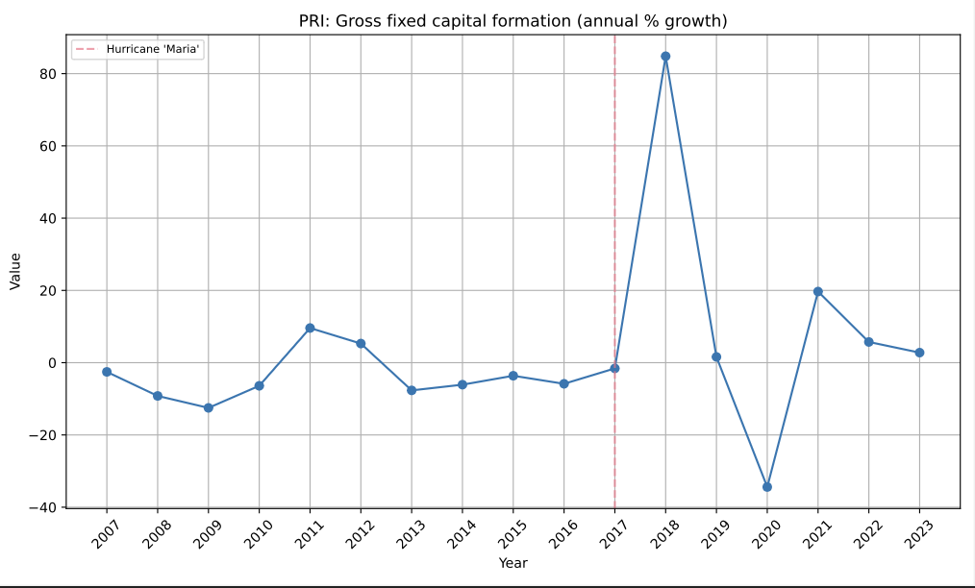

PRI: Gross capital formation (constant LCU)

PRI: Gross capital formation (% of GDP) Those jolts aren’t very permanent. The economic data doesn’t really have to do terribly with storms. Natural stuff (emissions) and public perception is what gets messed up.

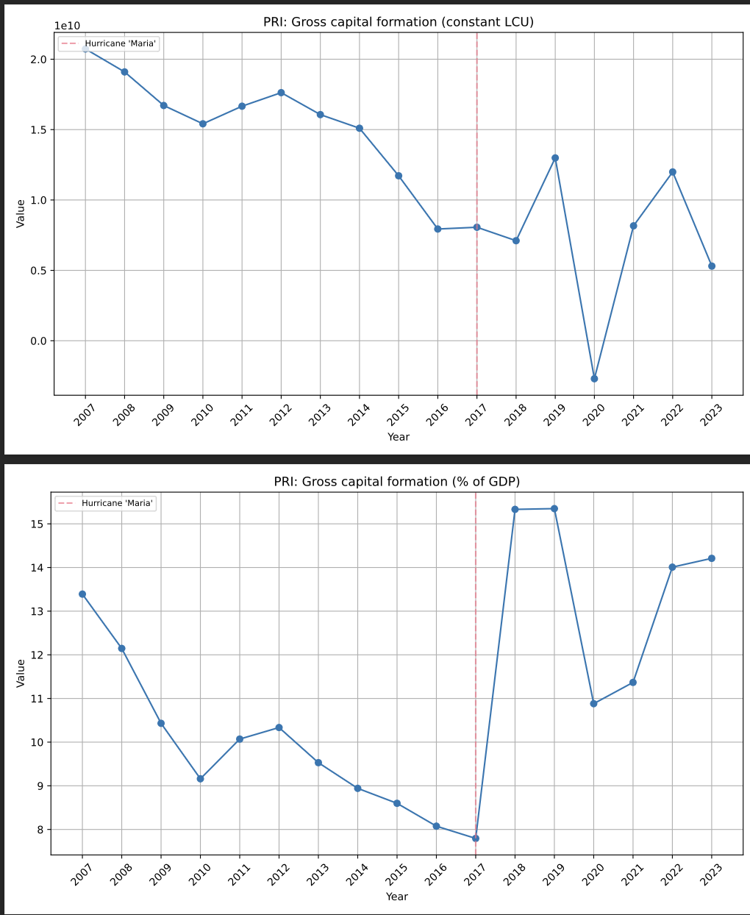

PRI: Imports of goods and services (current US$). Tracks with export data… but doesn’t recover

PRI: Imports of goods and services (% of GDP) like it did. There’s a permanent econ effect here.

A less productive country, relying more on external parties for goods and prof services… or maybe it’s access to the internet for knowledge stuff? More people do get on bandwidth.

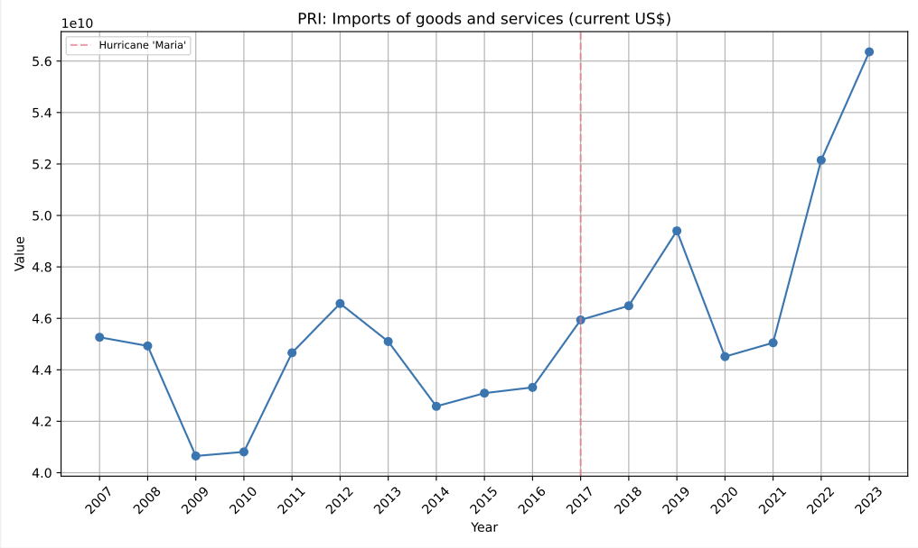

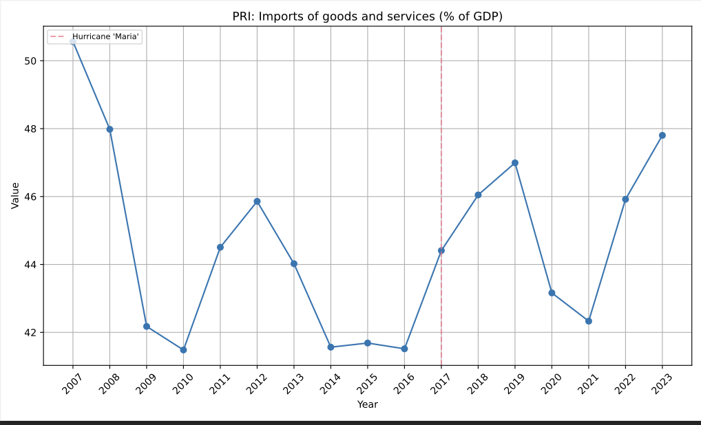

PRI: Fixed broadband subscriptions (per 100 people)

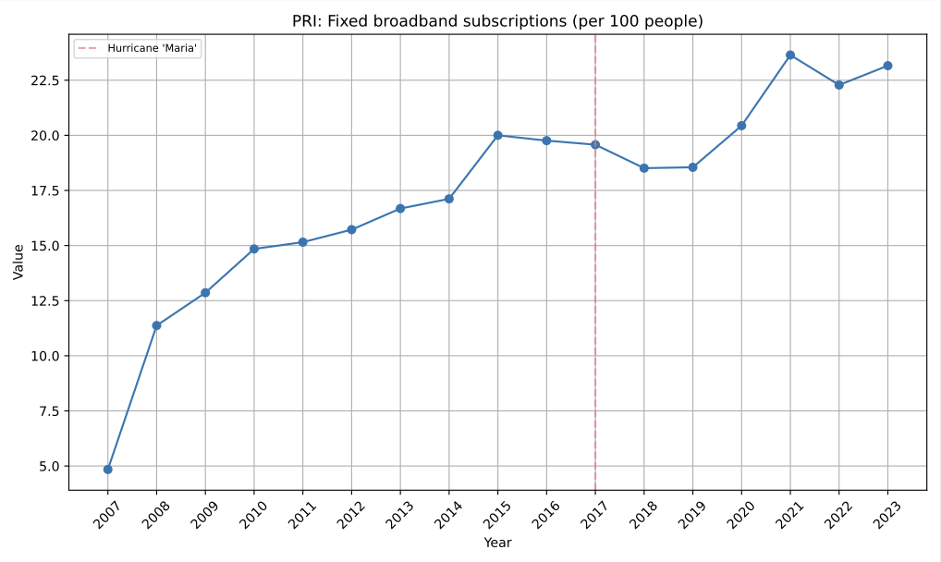

PRI: External balance on goods and services (current LCU)

• The external balance (exports - imports) peaks in 2016 at over $2.5 billion (LCU).

• After 2017, there is a sharp decline:

• Drops below $1 billion in 2020.

• Continues declining, nearing zero by 2023.

• This suggests that Puerto Rico’s imports are increasing relative to exports, pushing the balance closer to a potential trade deficit (negative balance).

PRI: External balance on goods and services (% of GDP)

• The external balance as a share of GDP shows a similar trend:

• Peaks around 25% of GDP in 2016.

• Declines sharply after 2017.

• By 2023, the external balance falls below 5% of GDP, indicating a rapid erosion of trade surplus relative to the size of the economy.

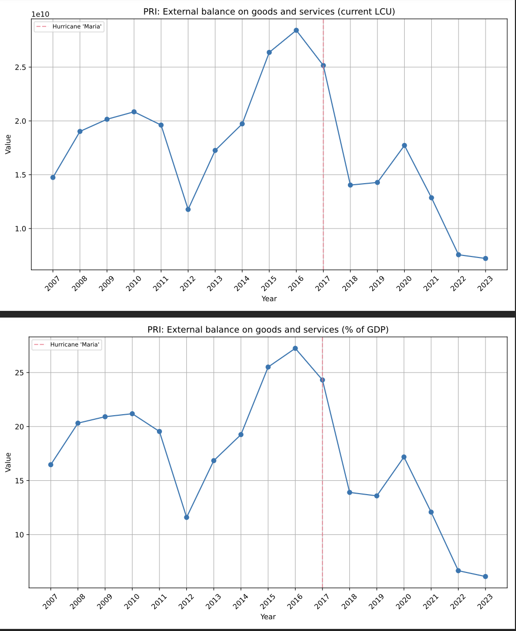

PRI: Adjusted savings: particulate emission damage (current US$). The air quality just got worse and it’s affecting the economy.

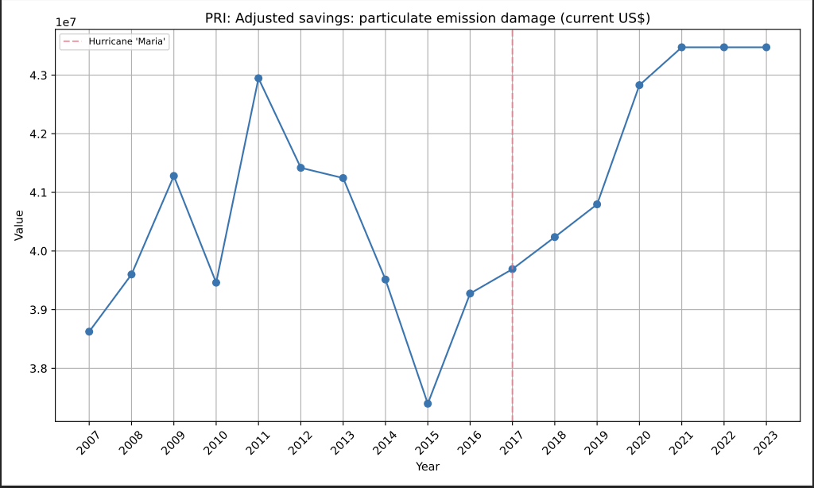

PRI: Discrepancy in expenditure estimate of GDP (current LCU) . This is about discrepancies in reporting. Maybe supports idea that efficiency has gone down and corruption feelings up.

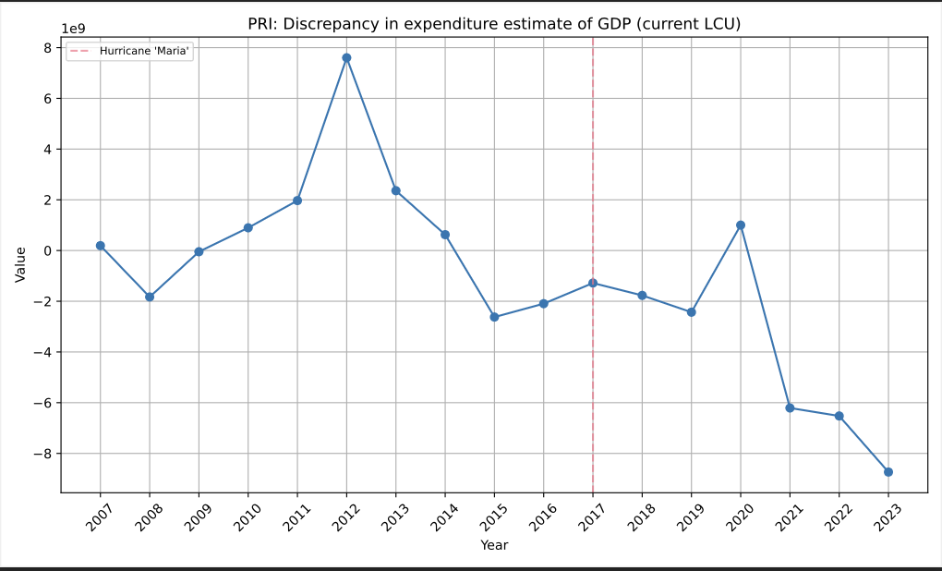

PRI: Gross domestic savings (current US$). People drained their servings in the aftermath and the economy still just got worse.

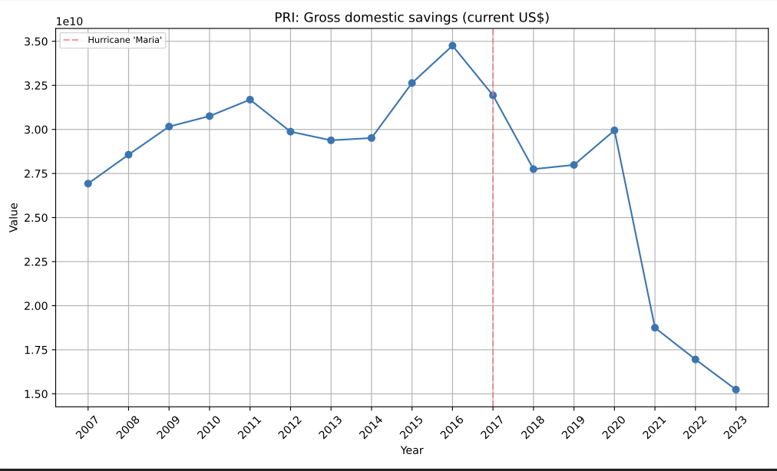

PRI: Price level ratio of PPP conversion factor (GDP) to market exchange rate

PRI: PPP conversion factor, private consumption (LCU per international $)

since 2007, goods and services in Puerto Rico have generally been cheaper than in mainland USA, costing about 77-95 cents in Puerto Rico for every dollar in the mainland, with prices being closest to mainland levels right before Hurricane Maria hit in 2017, after which they became increasingly cheaper compared to the mainland. People may just be terribly crunched.

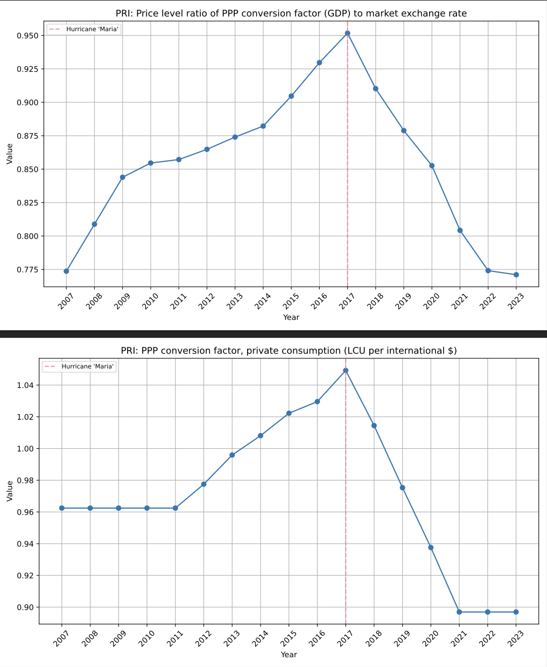

PRI: School enrollment, tertiary (gross), gender parity index (GPI). This seems interesting, but I know this also happened in the mainland.

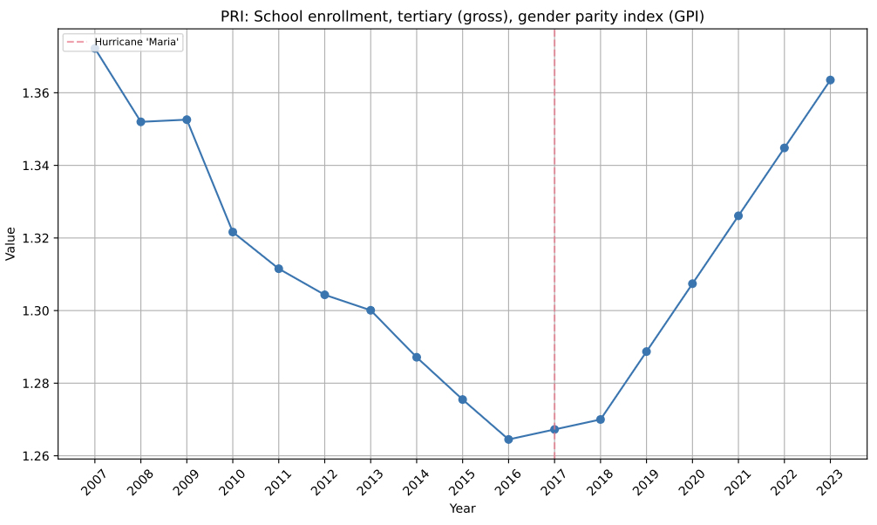

PRI: School enrollment, primary, female (% gross)

PRI: School enrollment, primary, male (% gross). But also PR is emptying, maybe there’s more women than men left?

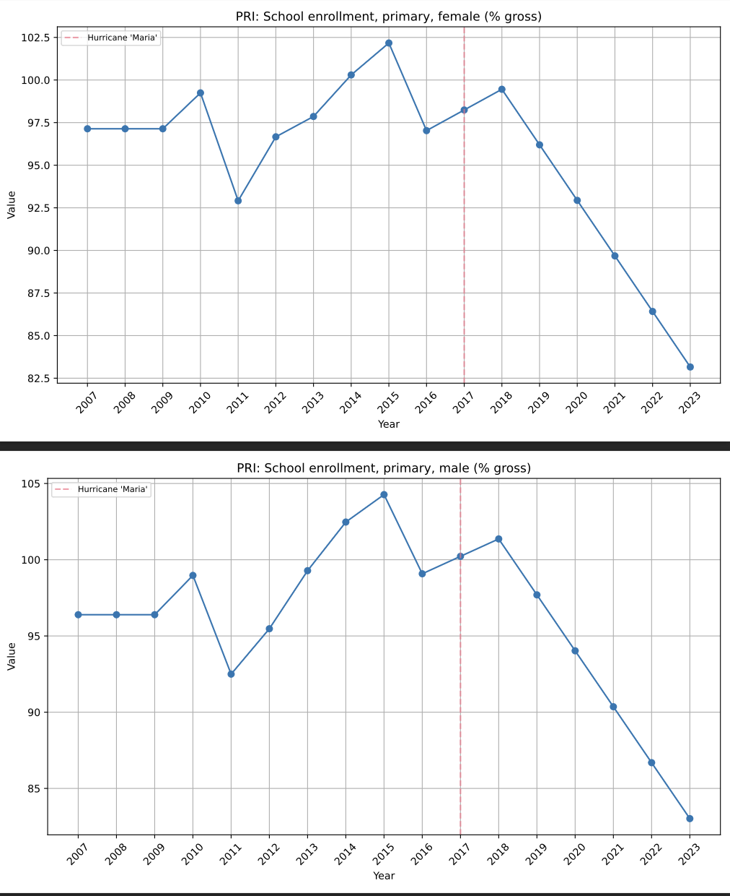

PRI: School enrollment, primary, private (% of total primary). Public schools are anecdotally worse and the Gov did close a bunch of public schools post-Maria, they keep losing enrollment, and the private sector picks up the slack. Maria made everything public worse. Or at least the policies chosen by the Gov. No wonder corruption and efficiency indexes are worse. COVID definitely accelerated it.

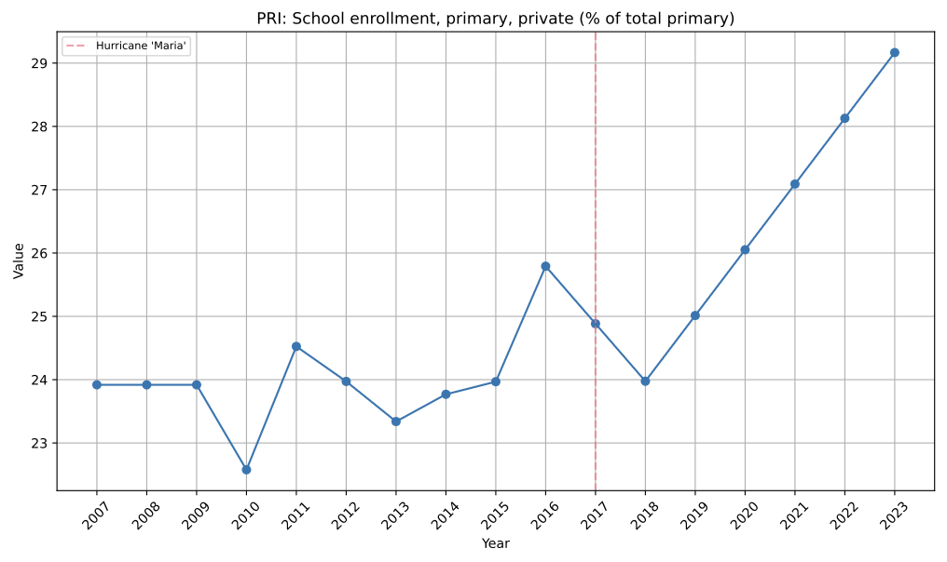

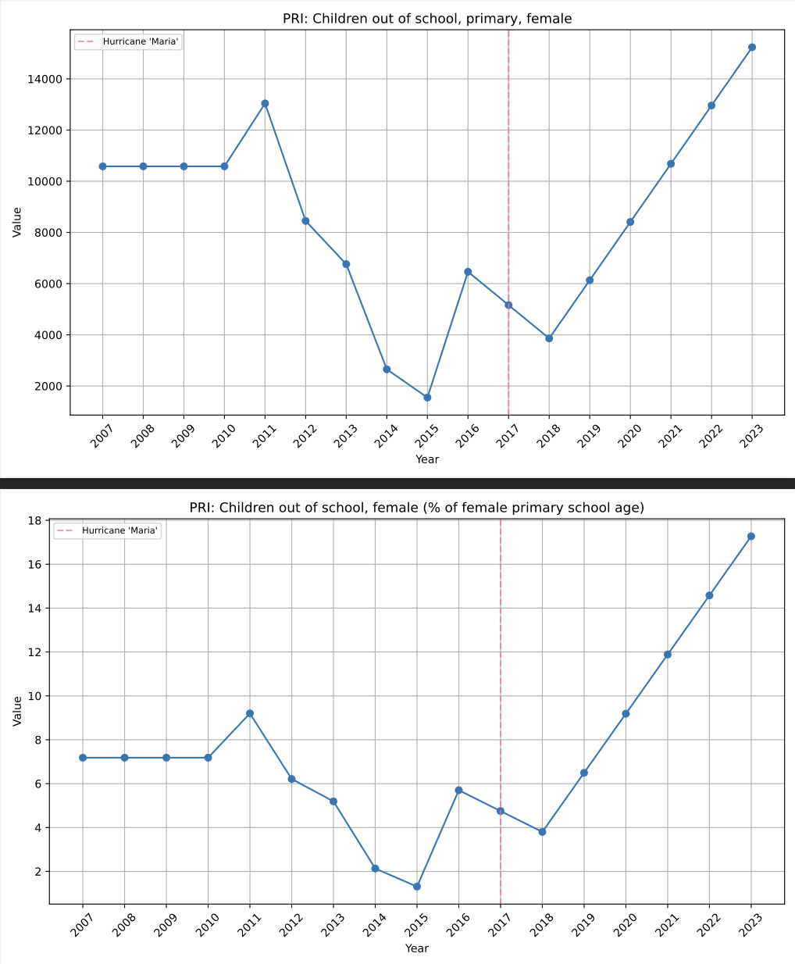

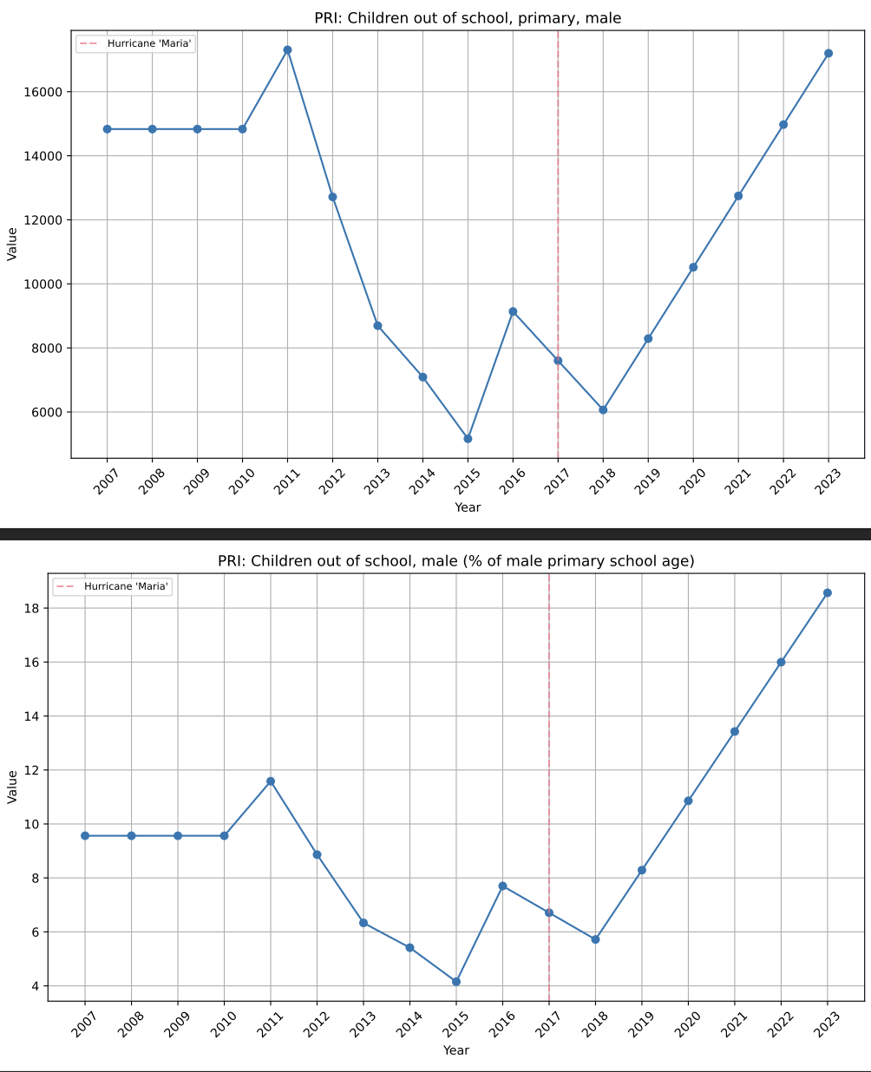

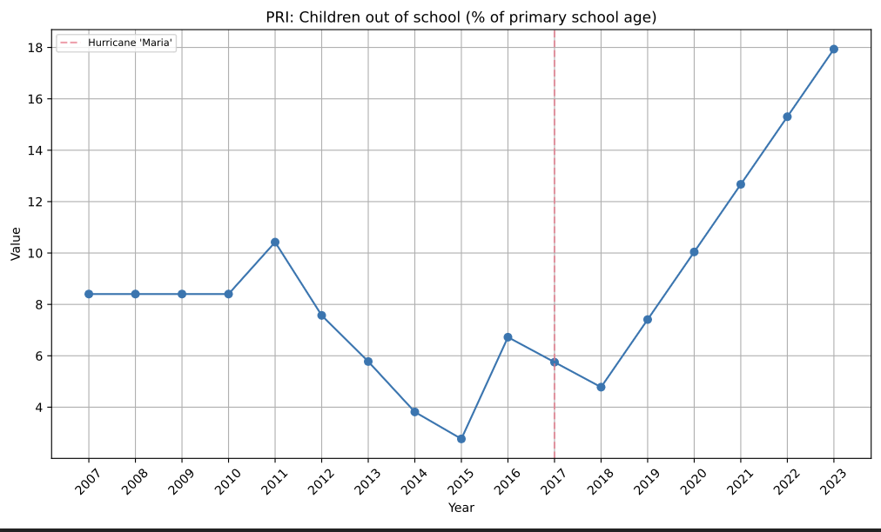

🡨

PRI: Children out of school (% of primary school age)

PRI: Children out of school, male (% of male primary school age)

PRI: Children out of school, primary, male

PRI: Children out of school, primary, female

PRI: Children out of school, female (% of male primary school age)

Oh this is awful. COVID definitely has to do a lot with it, but it started before Maria, and Maria most definitely accelerated. The slope is sharper post-Maria. The years seem a lil wonky, though. I have to look at what school year these things measure… because more people did get matriculated immediately after Maria… or they left and then came back?

**The population that left and came back seems critical here.**

🡪

PRI: Children out of school, male (% of male primary school age)

PRI: School enrollment, secondary (% gross)

Yes, people left, came back. But it does kind of seem like people with younger children stayed away. Older ones came back. Verify.

These only seem important in the context of primary stuff, otherwise the trends start before Maria.

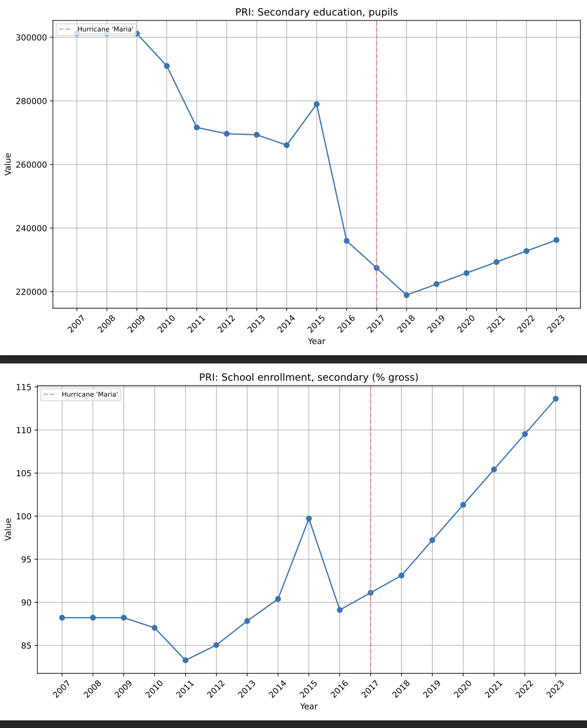

PRI: School enrollment, secondary, female (% gross)

PRI: School enrollment, secondary, male (% gross)

Are the % up because people are leaving?

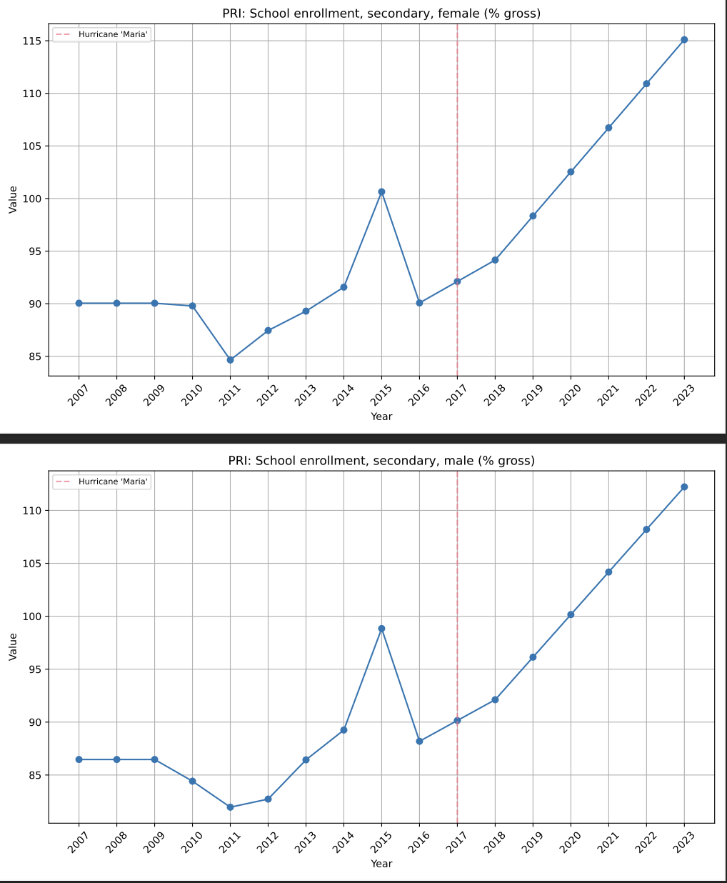

PRI: School enrollment, secondary, private (% of total secondary).

INTERESTING. It’s the primary school kids that went private. Secondary school and beyond people came back, and stuck to what they knew. Primary age ones stayed away, and then

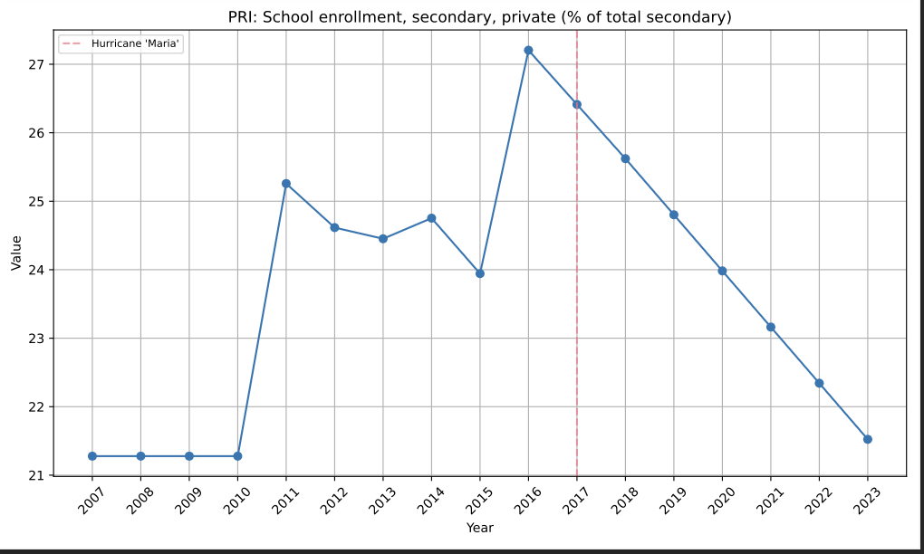

PRI: School enrollment, tertiary (% gross)

PRI: School enrollment, tertiary, female (% gross)

PRI: School enrollment, tertiary, male (% gross)

Yeah there’s something about the years. It’s probably by school semester or something.

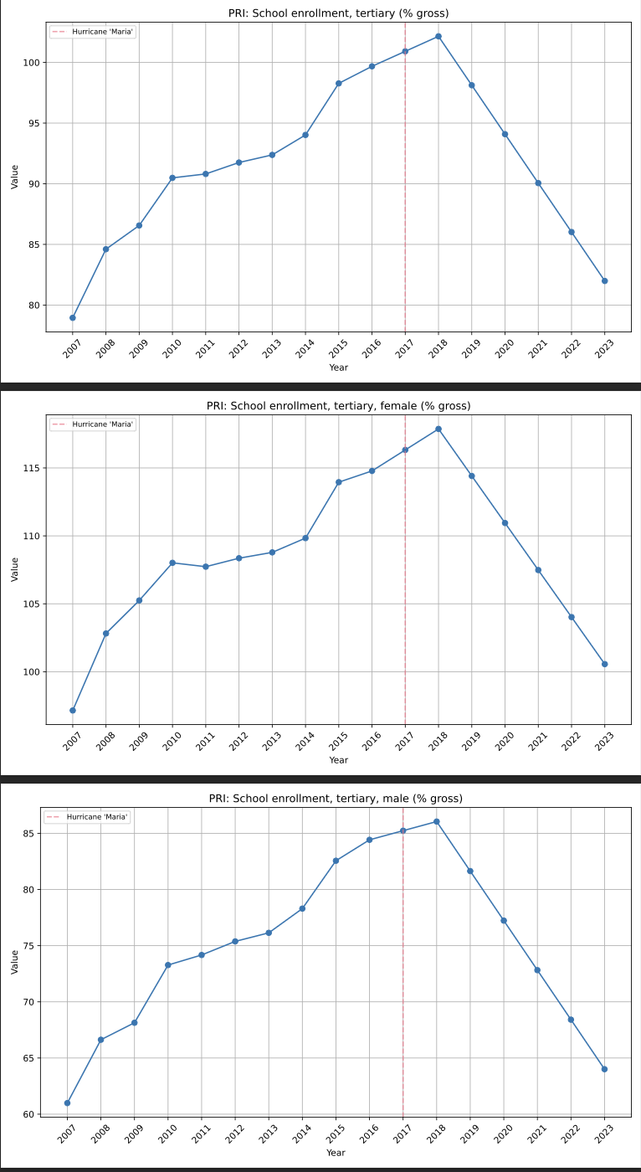

PRI: Employment to population ratio, 15+, female (%) (modeled ILO estimate)

PRI: Employment to population ratio, 15+, male (%) (modeled ILO estimate)

Seems like women began participating in the labor market at greater rates post Maria, a trend that has continued. Men have been participating more for a while now. Maybe more women have found independence, and that’s why more of them are going to college? But I bet there’s a level of ‘forced to’ here.

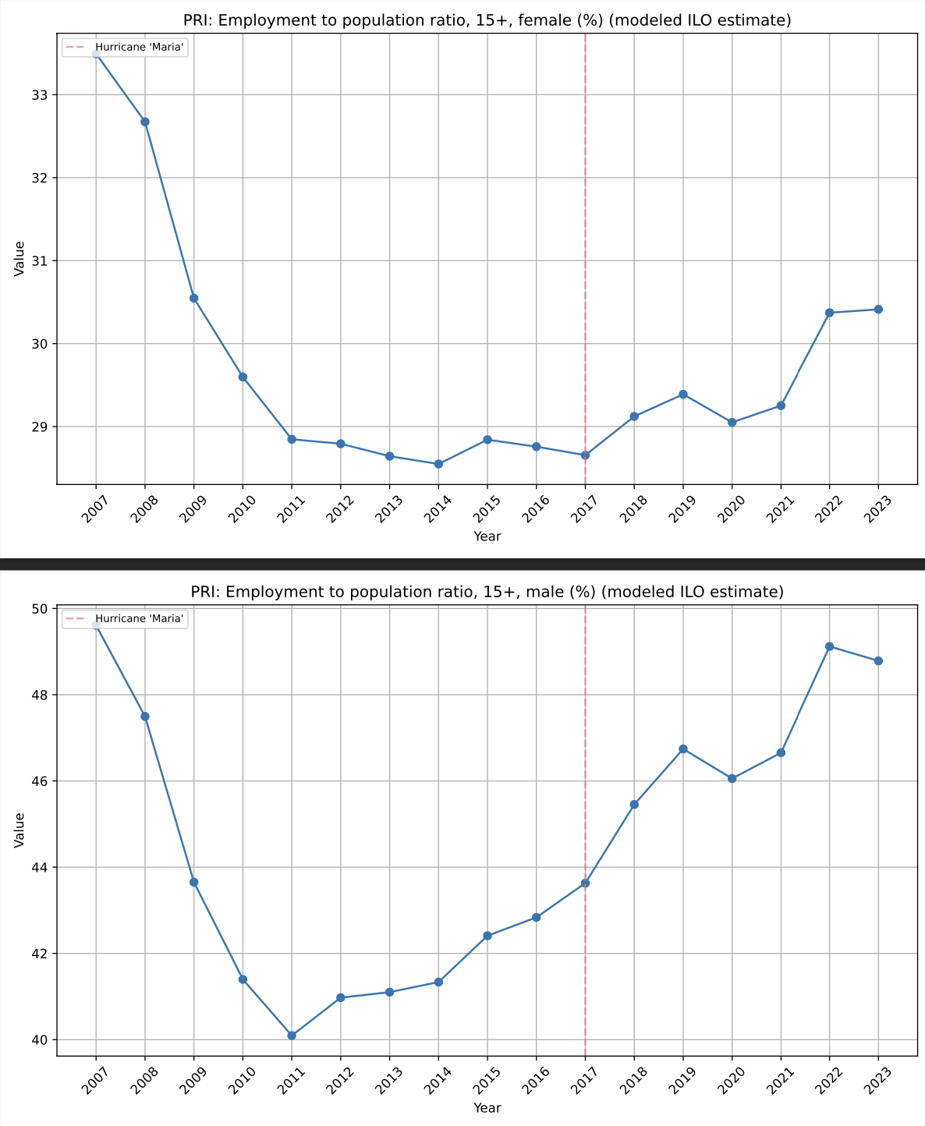

PRI: Net migration. Puerto Rico was consistently losing population… until Maria. In combination with dwindling savings, this may suggest that people just did not have the means to leave. Perhaps combine this with women jumping into the labor force to demonstrate this. Also, less people leaving, but services exports going down… I don’t think there’s any more well-educated people that can leave. Things ARE cheaper though, and COVID had everyone locked up… so the low skilled perhaps found it opportune to come back. Might as well be low paid and locked up where things are cheaper.

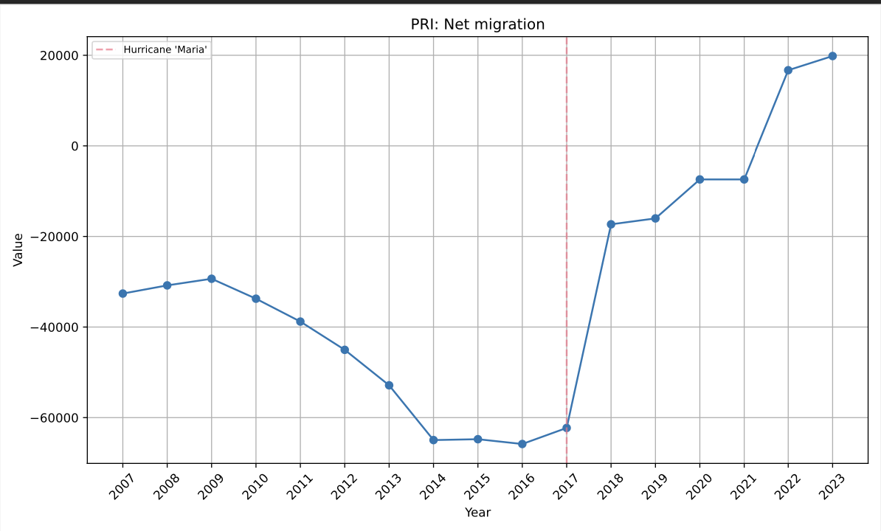

PRI: Mortality rate, adult, female (per 1,000 female adults)

PRI: Mortality rate, adult, male (per 1,000 female adults)

Man, a lot of people died, and continued dying. The mortality rate for men hasn’t gone down since Maria and COVID didn’t help. PR is also just old.

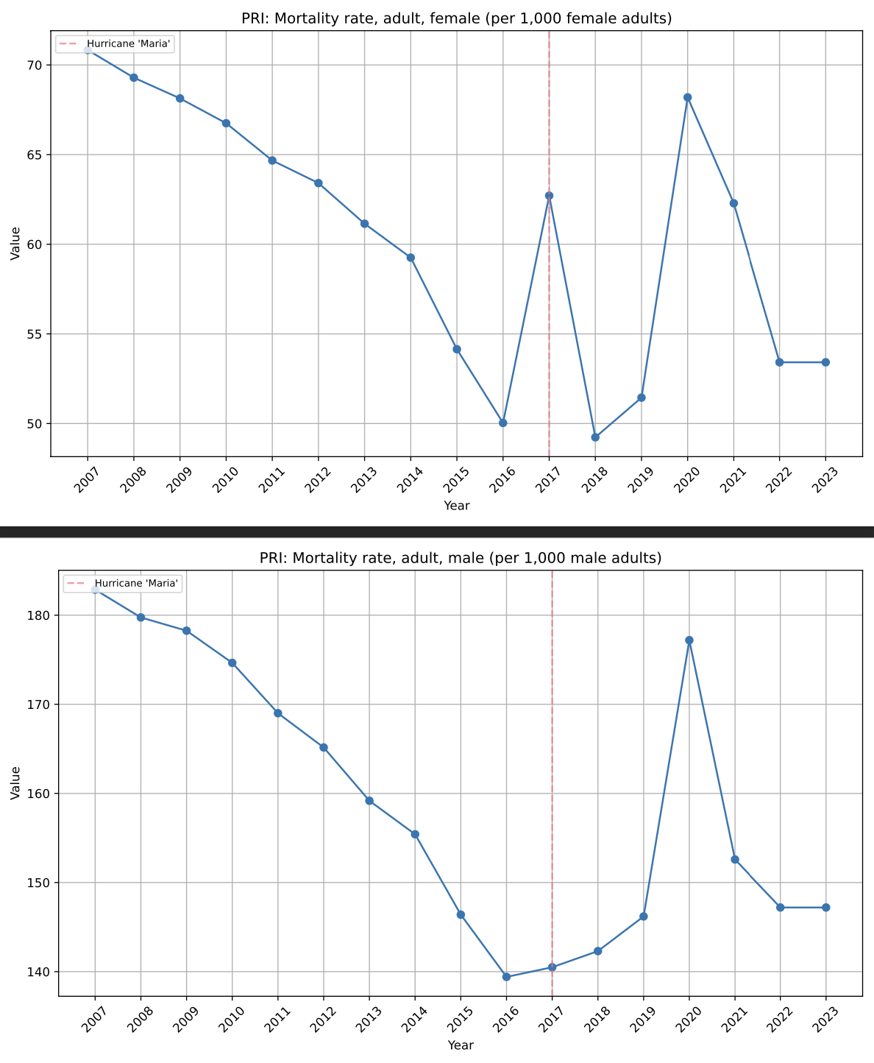

PRI: Death rate, crude (per 1,000 people). PR is old.

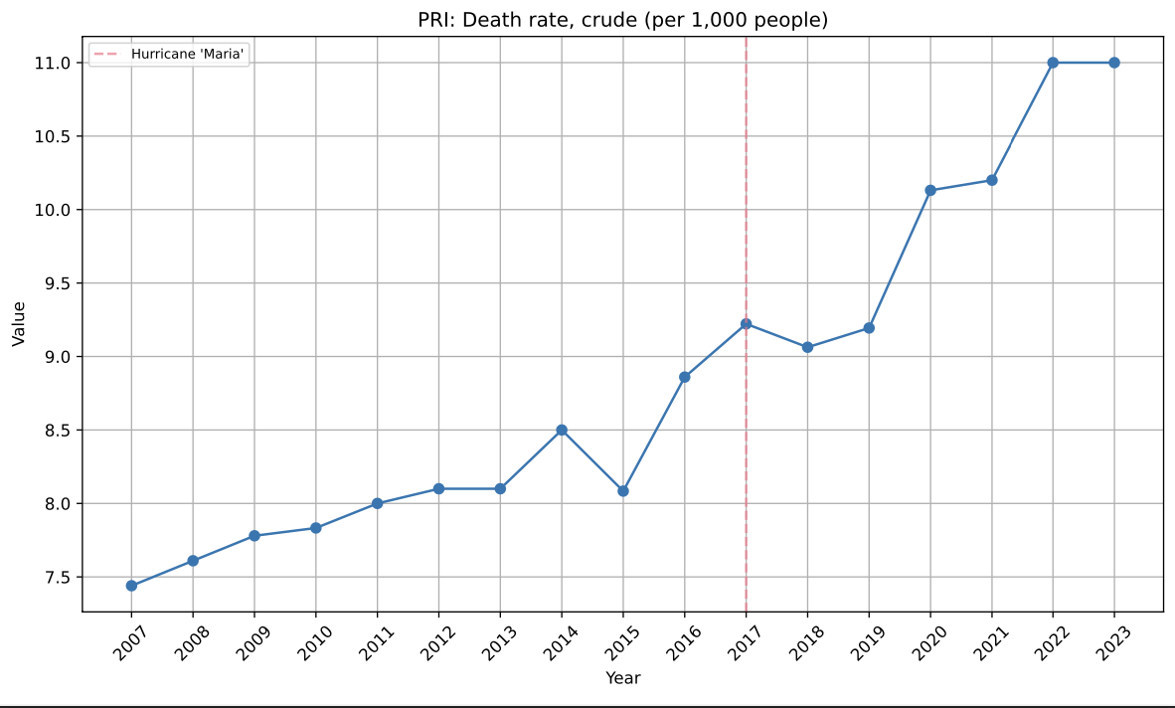

PRI: Population ages 00-04, female (% of female population)

PRI: Population ages 00-04, male (% of male population). Old.

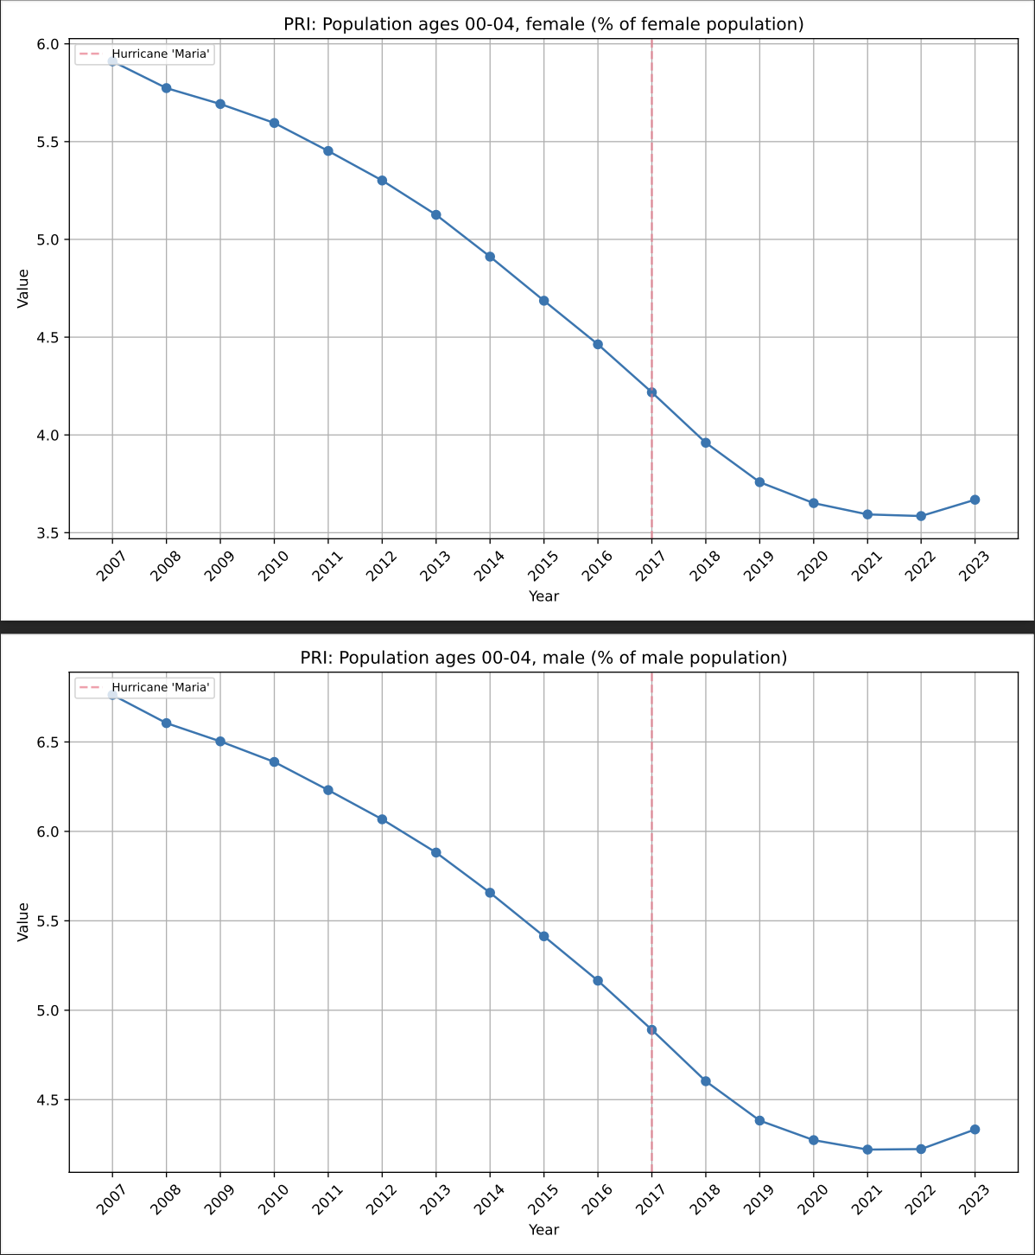

MORE POPULATION STUFF. Not only is Puerto Rico old, more old people started leaving or dying post-Maria. Worse healthcare, Drs leaving. Etc. Particular impact on middle age/earlier old age.

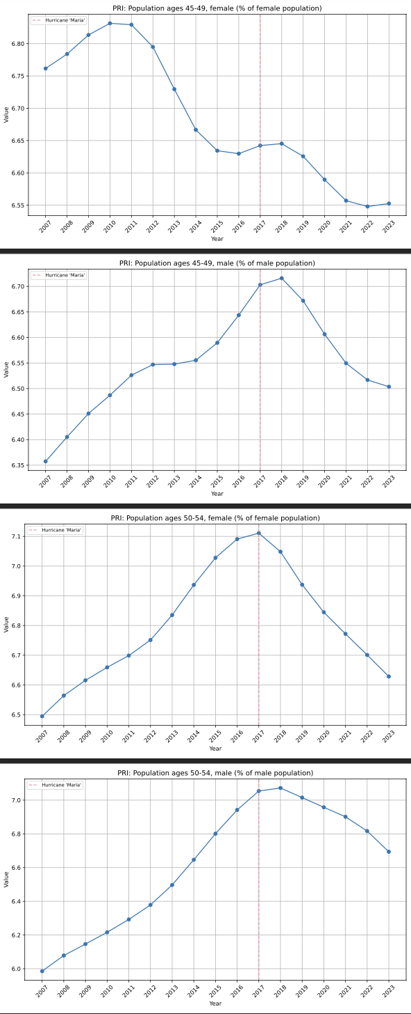

PRI: Population growth (annual %) . Interestingly, this may change our outlook on what the net migration plot actually says. If less people left, but population growth went down…

were they counting temporary reconstruction workers as migration-in? Or does this confirm that a lot of people just died.

